**ANGULAR 9 Training**

Software Required: NodeJS

VS Code (preconfigured with typescript extension, need to add Angular language service. TypeScript compiler not present. Nut no needed as CLI will do the compilation) or VS 2017 or VS 2019 ()

Angular Js library written in **JavaScript**.

* Rest Angular Versions library written in **TypeScript**.
* Angular team release a major version every 6 months.

Material – angular.io

Also, every version is backward compatible with previous one is taken care of by dev team.

Directives

Angular **is Framework because it has its own ways to implement the feature** (built in feature). You just need to use it. It does not need to depend on others. So, it is a framework. ReactJS does not have DI, Lazy loading.

Library

**RXJS** is a dependency which gets installed automatically.

It is a client-side framework and lib.

Used for creating Single Page applications => Made of one single page and that page contains all the aspects of the application. Benefit is no server call made. It looks like you go to diff page but in-reality you do not. Component is nothing but a part of a view.

For rendering the component, the server call is not made. There is no server round trip. Navigation, between click, hyperlink all clicked routes to a component. But server call is not made. As in other applications where a server call is made on an action perform.

Frameworks can be integrated also because all are JS libraries.

All components will be available at one time only.

Output of an Angular application is JavaScript. Browsers can read only JS.

Angular used typescript so it is preferred and TS has all OOPs concept compared to JS. But TS is converted to JS at the end.

**Architecture**: Client requests for a page=> index.html and this page has all the components. It will be deployed on a server. Entire application along with index.html is rendered. And it is run by Angular framework (Angular runtime which is a part of browser will take charge of application) and not the browser.

**Components**: Angular uses MVC or MVVM design pattern architecture.

Component is just a part of a view. All components are inside one root component. Root component is like a container. Root component is the first component when a component is bootstrapped.

Every component has a controller (.ts file)

**Module**: A logical container for one or more components. (Similar to packages in JAVA => collection of classes).

All modules will be part of root modules. And all components will be part of Root Component. And Root Component is a part of root Module. Module are just a logical way of grouping components together.

**Advantage** – If I need you add a new feature to a component, we can work on them on module level and not to whole components in applications. You can load these modules on demand using a feature lazy loading.

Each module will be compiled as separate chunk of JavaScript. So, we can run some modules at run time and not when the application is bootstrapped because user may not be interested in some components (ex: about us) in modules. When user clicks on the hyperlink on about-us, it will get loaded.

Hence, we can load modules on demand. So, we have eager and lazy loading (configured using routing). So, these modules which are part of root modules are feature modules. Each module will be compiled as a separate chunk.

Root module is always loaded eagerly. Depending on the feature modules configuration(eagerly/lazy), the modules get loaded. So, we need to divide other components in modules.

**Pipes**: used to format display/data in the view. Ex dd-mm-yy to dd/mm/yyyy

Build-in pipes/ Custom Pipes

**Directives**: Similar to component. It is like a html attribute which can change behavior to html element. These directives are programmed in html.

Built-in/Custom directive. Difference compared to component is that component has a view but directive does not. A component is a special kind of directive used to render view. A directive is not a component though.

**Routes**: Used for navigation.

Specifies the path to a component.

If URL is **/home**, then display Home Component.

**Services**: Common logic to be shared between multiple components.

Uses the built-in Dependency Injection mechanism.

**Template**: HTML/HTML-5 code + Angular Syntax = View

**Angular CLI**: npm install -g @angular/cli

**CLI Commands:** ng <command name> [<options>]

ng new <application name> => asks for routing and style type (CSS, scss …)

All the components will be a part of app folder. [src] -> [app] -> [code]

Package.json -> SIGNIFICANCE => all dependencies are listed out here

* devDependencies -> not included in build. Required only during development
* dependencies (runtime Dependencies) ->

To install Bootstrap, we do **npm install –save bootstrap**. It is an external library. The package.json files will get an entry of bootstrap on its own. By Default, it goes as runtime dependency.

**Adv**: We can copy package. json on different machine and do npm install.

**--save** will make an entry in the dependency section in the package. json and will install a folder in node_modules folder.

For devDependencies, we **have npm install –save-dev bootstrap.**

**ng serve** -> compile the application. Make application ready to execute. Makes development build not production build.

In index.html, we see <app-root></app-root>. When you say localhost:4200, the browser fetches for the index.html page.

Root Module -> app.module.ts

Every module has some meta-data. We have NgModule decorator above class. This decorator has some.

TypeScript class to component -> @Component and for module -> @NgModule.

There can be multiple Root Component. By default, an application has 1 root component.

**BOOTSTRAP process:**

Angular run time is bale to understand <app-root>. Html cannot read <app-root>.

Then angular application starts bootstrapping.

1. **main.ts** executes platoFromBrowserDynamic() returns a JavaScript application which load the Root module. The constructor (if made in app module) of App module will be called. Main.ts runs (default) in a development mode due to variable in environment.ts to false.
2. **Angular checks if the selector of app component is written in index.html or not. If not, it throws an error. If yes, template in rendered in DOM.**
3. In app module, app component is bootstrapped => That means the constructor of app component is called since App Component is written in Bootstrap property.
4. In app component, due to the selector property in component decorator, template is called.
5. If you generate one more root component, its selector must be present in the index.html.
6. We cannot put anything inside the app root tags in index.html because, app-root tags indicate calling of app component template.

In angular.json, all the configurations are mentioned i.e. which is the index page and main.ts etc. etc. if you renamed the files, you need to update that too in angular.json

Polyfills come in picture which makes your application works on legacy browsers.

Styles.css -> global styles to the application. Import bootstrap here.

**@import ‘../node_modules/bootstrap/dist/css/bootstrap.css’;**

**Creation of component** – Component forms a part of a View.

Contains a template, logic (controller / view model), metadata.

Every Component should be a part of a module. (Root Module)

.ts file (controller / view model)

.html fie (template)

ng generate component <component name> **OR**

ng generate c <component name> **OR**

ng g c <component name>

This will create a component inside app (ROOT) component.

Any component you create will have a suffix Component.

EX: for component login -> filename will be login.component.ts

Class name will be Login Component

EX: for component logincomponent -> filename will be logincomponent.component.ts

Class name will be Login**c**omponentComponent

EX: for component hello-world -> filename will be hello-world.component.ts

Class name will be Hello**W**orldComponent

On running command, 4 artifacts are generated and app.module.ts is updated.

A component needs to be declared in the declaration property in NgModule. If not written, angular will not compile the typescript code.

* **Which component is a child of what depends only on where you have placed the selector of the component.**

If we remove the metadata of the class, angular runtime will treat the class as a normal class and not as a component. (error - <component-name> is not a known element)

It gives an error: Angular JIT (Just In time) compilation failed.

Ng generate has a lot of commands in it – see angular.io

ng g c welcome –inlineTemplate=true -> will not generate a html file. Will generate an inline template with backticks (``). It is used when template is small. It will have a template property instead of template URL.

ng serve not only serves you but also builds the application. It is in serving mode here. You cannot see JS file here. But in ng build you can see the JavaScript files.

**Data Binding:** technique to keep the model and view in sync

1. **One Way Binding:** (Flow of data from model to view) Used for read-only scenarios
   1. Interpolation syntax {{}}
   2. Property Binding []
2. **Two Way Binding:** (Flow of data from model to view and vice versa) Used for read/write scenarios
   1. ngModal directive -> Combination of property and event binding. [(ngModal)]
3. **Event Binding:** (Flow of data from view to model)
   1. (event) = “method” => the body method has to be written in ts file

**(click)=” handleLogin($event)”;**

$event gives the details of the html element that generated that event. This parameter is optional. (Gaining info of the event)

* 1. **Template reference variable (if not want to use $event)**

**<input #variable (click)=” HandleKeyEvent (variable.value)”/>**

The template reference variable has all the properties of the html element. So, use it when you want to access properties of element. It will not give you the details of the event.

Use $event when you want to know the event properties or event related information. It is generally not good to use since it passes the whole event object.

So, use $event – to get info about event inside a handler. It contains the element data also.

Use Template reference variable- to get info of element of event inside the handler.

* 1. A **Template reference variable** can be accessed anywhere inside a template. So, if you want to access a **Template reference variable** inside class, we use @ViewChild.

**Diff between property and interpolation**:

In html, certain elements have got attributes and certain elements have got DOM properties.

<h1 style=” color: red” align = “center” ></h1>.

Property binding binds to the DOM property. Align is an attribute but color is not. So, we have to use

DOM property and apply color on it.

Binding to DOM elements – use property binding (better to use)

Binding to the string/text elements – use interpolation

ngModel – we have to import FORMS-MODULE in root module since it is not a known attribute.

**Component Communication:**

Parent ----------> Child

Input () decorator

ViewChild () decorator

1. In Child Component, create a data member decorated with @Input ().
2. When rendering the child component from the parent use **property binding** syntax. Use the child component input member name to pass the data.

<child [childPropertyName]=” expression”></child>

**Significance of @input**: Any data member decorated with input in child can be used by parent using property binding.

Child ----------> Parent

Output () decorator

EventEmitter class

1. Create **an EventEmitter (it is a class) instance** decorated with @Output ().
2. Child emits the event passing the data to the parent. child property will call emit ().
3. Parent component subscribes to the event emitted by the child and extracts the data from the event handler. **Using event binding syntax**
4. Since we have to extract the data, we have to pass the $event.
5. If you want to pass multiple values or object in the emit, change the generic in the EventEmitter instance created.

**So, @input used property binding and @output uses event binding.**

**@ViewChild**: If a child class function has to be invoked from the parent.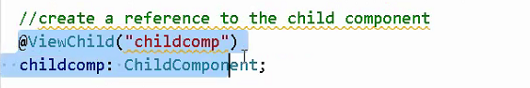

1. Create a data member of child decorated with @ViewChild in parent component.
2. Specify a template reference variable in the child selector written in parent html.
3. Pass the template reference variable in the ViewChild.

Sibling Components:

Service

RxJS Library

**Directives**: Specialized attribute whose functionality is written in angular and can be used in template.

1. Component Directive (Components) Have their own templates
2. Attribute Directive (One that changes the behavior of the html element to which it is applied)

<element **[directiveName]**=” arguments”></element>

**ngStyle, ngClass, ngSwitch**

1. Structural Directive (Changes the DOM structure by adding or removing elements)

<element **\*directiveName**></element>

**ngIf, ngFor** (element gets cloned on which it is applied)**, ngSwitchCase, ngSwitchDefault**

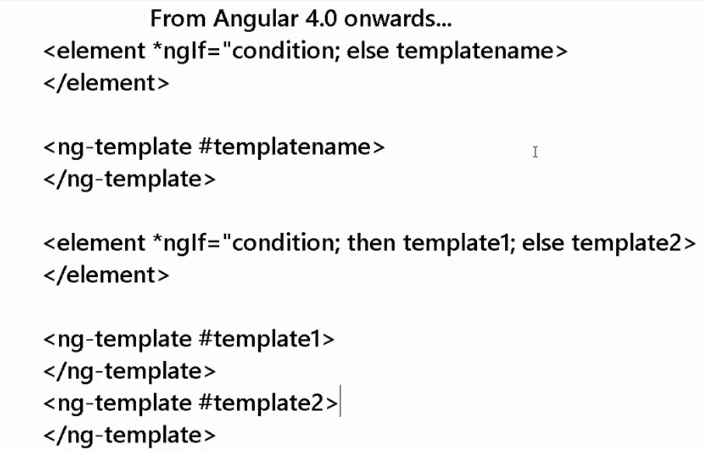

Initially when the page is loaded, the ng-template is not rendered. It is just a chunk of html which will get rendered only if the condition is met.

**Custom Directive: --------------- > Incomplete**

1. Create a typescript class decorated with **@Decorative** decorator.

**ng generate directive highlight** (There is no template generated). The directive is directly put inside the src-->app folder. There is no special folder generated for that. The class name will be **HighlightDirective** and selector will be appHighlight.

1. Use the **@HostListener** decorator to respond to events on any method.

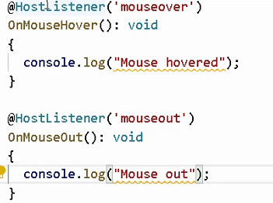 

1. Use the **ElementRef** service to get access to the host element.

<element [appHighlight] =” red”></element> ------ > with propertyBinding **OR**

<element appHighlight></element> ------ > without

ElementRef is a service in Angular library. You have to inject it inside constructor of the directive. ElementRef will be like a wrapper or a box for the element on which the directive is applied. It has got a property nativeElement for this.

Inside the directive class, first inject the element using nativeElement.

1. To use <element appHighlight [color] = “‘red’”></element> i.e. passing arguments,

Use @Input decorative. We can also use it as,

<element appHighlight [color] = “‘red’”></element>

@Input(“appHighlight)

appHighlight: string;

For custom **structural** directive- go through MICRO-syntax first

**Pipes**: Build in pipes and Custom. (ng g pipe demo) ---- > class name will be **DemoPipe**

Decorated with **@Pipe** and has a function --- > **transform (arg1, …. Spread operator)**

Formatting the data. It takes some input, transform it and produces the output.

Used in HTML template **OR** inside Typescript code.

{{expression | pipename}}

{{expression | pipename1 | pipename2 | pipename3}} ----- > chaining of pipes

{{expression | pipename: arg1: arg2: arg3: ……}}

Each built-in pipe may or may not take arguments. Some are -

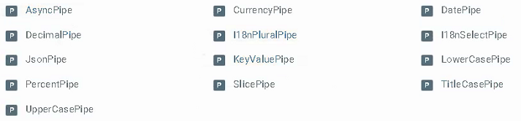

Every custom pipe implicitly takes one argument and this argument is the value on which this pipe is applied.

Html used in ts file to work --- > use property binding [innerText] = “var | pipe”.

Html will be executed and we do not need sanitizer for it. But in order for script written in ts file to get executed we need DOM sanitizer.

**DOM Sanitizer**: <https://medium.com/@swarnakishore/angular-safe-pipe-implementation-to-bypass-domsanitizer-stripping-out-content-c1bf0f1cc36b>

<https://angular.io/guide/security>

Backticks do not by pass the trust. It will only indent the strings. If written <td><tr>, it will print it as it is.

**Pipes: Pure pipes --- >** Angular will call transform () whenever it detects change in any primitive type (string, Boolean, number) i.e. Object reference changes. Angular will not call the transform () if change is made to property of an object.

**Impure pipes ---** > change after every change in DOM, add/delete/change property

By default, pipes are pure. So impure pipe degrades performance.

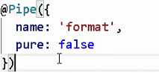Default value to pure is true.

**Creating feature Modules:**

ng generate module <name>

[app]

app. component.ts

[feature module1]

Comp1

Comp2

[feature module1]

Comp1

Comp2

These feature modules must be imported by app module.

These components must be declared by feature module. So, no need to declare the components in app module.

To create a component in feature module, we have to change the path or else the component gets created in app module.

**ng generate comp1 –module feature1**

Whenever you create a component inside a module, they are **private** to that module. So, we cannot use those components in other modules. If you want to use the components in other modules, we have to enhance the command to write in export property or you explicitly add the component in the export property of the module.

**ng generate comp2 –module feature1 --export=true**

Also, by default all modules are eagerly loaded in the app module. Here comes eager and lazy loading.

**Angular service:** Can also be used to pass data between components

Enables you to use some common logic across components

**ng generate service <service-name>**

Class is decorated with decorator **@Injectable**. This decorator makes it a service. Any class with this decorator can be used by DI of angular to inject it in classes, pipes ... Also, it has a property “**providedIn”.**

A singleton service is a service for which only one instance exists in an app.

**Providing a singleton service**

There are two ways to make a service a singleton in Angular:

* Set the providedIn property of the @[Injectable](https://angular.io/api/core/Injectable)() to "root".
* Include the service in the AppModule or in a module that is only imported by the AppModule

**i.e. Import the service in AppModule and Use the providers array of NgModule**.

**Levels of injector**: It is a piece of code which will create an instance of the provider.

**Root Level Injector** (Application level)

Provider is the class which will allow us to use the code and tells how to create the instance.

There is one provider and an injector. Provider is the services you create. Injector is registered/connected with provider using @[Injectable](https://angular.io/api/core/Injectable). Value root makes it available to whole application.

**Module Level Injector**

Service available only inside the Module. ProvidedIn value inside service should be kept **the module name** here. It is used only when module is lazy loaded. If used with eagerly loaded, service will be available at root level.

**Component Level Injecto**r

For this, we have to register it in the providers array of @Component decorator.

It has nothing to do with loading -eager / lazy.

For each component, a new instance of service is made even if both the component is in same module.

<https://www.pluralsight.com/guides/registering-services-with-the-providers-array-in-angular>

If parent has service in providers array in its component. Will the child component use the same instance or will this service available to child component???

------- > It will be available to all child components but if child component explicitly adds service in its providers array, it will use its own instance.

How the DI mechanism resolves services i.e. **the search mechanism**?

1. Component Level Injector
2. Parent Component Injector
3. Module Level Injector
4. Root Module Level Injector

If injector is not provided by any level then only it searches on the next level. If it is not provided anywhere, it throws an error --> no Provider for Service

**Control this search mechanism (@angular/core) by-**

**@Optional ()** ---- > If service is not available, to prevent the error msg this is used. Resolves to **null** if the service is not available

**@Self () --- >** Angular will search the injector only in current component. Do not proceeds further

**@SkipSelf () ---->** Will start search mechanism from the parent and proceeds upwards if search not found in parent or if the service is not resolved.

**@Host ()** ----- > specifies a component where the search operation should stop.

At component level @Host is same as @Self.

@Host is hence useful for directives.

Service can be injected at component, pipes and directives.

@Host works for a component and the other component are not affected due to that. Say if written in parent component, the child will be able to access the service even if the service is written only in Root Module. But parent will throw an error since it will check in its component (if the injector is not found there, it looks for the injector up to its host component) and then in App component. It will not check in App module. Since it is not written anywhere except in App module, it will not be able to find it.

If a feature module is present, will the search go through feature module and then root component and then root module

<https://medium.com/frontend-coach/self-or-optional-host-the-visual-guide-to-angular-di-decorators-73fbbb5c8658#:~:text=%40Host(),up%20to%20its%20host%20component.>

**You can use a class provider, value and factory provider.**

**Providers: [Logger]**

**Providers: [provider: Logger, useClass: BetterLogger]**

**-------> [Root Module]**

**Root Component (Logger Service)**

**Parent Component (@Host Logger Service)**

**Child Component (Logger Service)**

So even if parent has the service in its component, it will throw an error. But if it is used in directive, and child component has service, it will not throw an error.



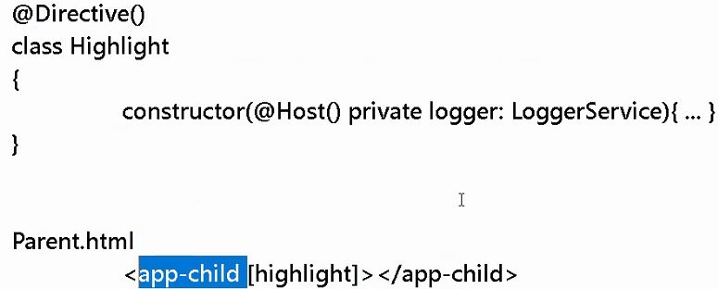

https://angular.io/guide/dependency-injection-providers#the-provider-object-literal

**Angular Component Life Cycle:**

Created<----------------> Destroyed

Life Cycle Hooks. Each hook is provided by an Interface.

We have to import these hooks like this in order to use it (**actually implementing the hooks is not mandatory but considered good practice**).

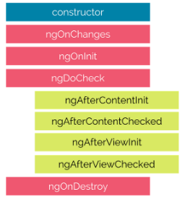

Constructors should not be used to initialize a value. Not invoked by angular run time. It is run by JavaScript or typescript.

The constructor is not actually part of Angular 2. It is feature of Typescript class, which is called when class is instantiated. Constructor is used to create new instance of a class. It can’t be used to decide when Angular has finished the initialization of component. In Angular, constructor can be used to initialize the fields and angular DI [ Dependency Injection] looks for constructor parameters to find providers and resolve dependencies and passes them as constructor arguments.

Since constructor is called by JavaScript engine not by Angular, ngOnInit lifecycle hook was created in Angular. ngOnInit signals that Angular has finished initializing and setting up component. The ngOnInit is called after the constructor is executed. In constructor Angular initializes and resolves all class members so in ngOnInit you can initialize work and logic of the component.

<https://medium.com/@coderonfleek/constructor-vs-ngoninit-angular-2-components-b1a33db0be65>

**ngOnChanges**

Invoked **every** time there is a change in one of the **@Input ()** properties of the component.

Ex: if you want to compare the previous and current value, this can be used

Will work only for @Input and not for a normal public property inside the component.

Has a parameter - **changes: SimpleChanges** having 2 properties, previousValue and currentValue

There in a method ngModelChanges () / setter and getters to monitor changes on public property inside a component.

**ngOnInit**

Invoked when given component has been initialized. It is like constructor of Angular.  
This hook is only called **once** after the first ngOnChanges

The initial value is available inside the NgOnInit

Write code here if you want to start from the previous values of the data loaded.

**ngDoCheck**

It is theoretically same as ngOnChanges. Changes detected in @Input.

It does not give previous and current values.

It is called for those changes which **angular cannot detect**.

Ex: @Input ----- > emp: Employee;

id, name, age and any one of them is changed. Here ngOnChanges will not be called.

Invoked when the change detector of the given component is invoked. It allows us to implement our own change detection algorithm for the given component.

ngDoCheck and ngOnChanges should not be implemented together on the same component.

**ngOnDestroy**

This method will be invoked just before Angular destroys the component.  
Use this hook to unsubscribe observables and detach event handlers to avoid memory leaks.

[**Hooks for the Component’s Children**](https://codecraft.tv/courses/angular/components/lifecycle-hooks/#_hooks_for_the_component_s_children)

These hooks are only called for components and not directives.

**ngAfterContentInit ---- > best place to use @ContentChild**

Called once after NgDoCheck

Invoked after Angular performs any content projection into the component’s view.

Content is an external html that is not present in the template of the component. It is written inside the tags of the component.

Used where <ng-content> used in template (i.e. child).

**ngAfterContentChecked**

Called once after ngDoCheckand called every time after there is a content change.

Invoked each time the content of the given component has been checked by the change detection mechanism of Angular.

---- > Called after angular finishes projection of external content inside angular template

**Content Projection**: **<app- search >**

**<p>Angular Training</p> < --- external content**

**</app-search>**

In a normal scenario angular will not print the text in side p-tags.

It is like an external content.

**<ng-content></ng-content>** is used to put the external data inside the template of app-search. This is going to be a part but is has actually come from outside. If you do not use these tags, the hook(**ngAfterContentInit**) will get fired but you will not be able to get access to that content.

Allow some type of outside text inside template.

You can select a particular slot for projection using the <**ng-content**> selector. There are four types of selectors:

1. Project using tag selector.
2. Project using class selector.
3. Project using id selector.
4. Project using attribute selector.

For Multi-Content projection, selectors are used.

Use of this hook: When you want to make changes in the external content

**ngAfterViewInit ------ > best place to use @ViewChild**

Invoked when the component’s view has been fully initialized. (Including Child component selector inside parent’s template).

Invoked only once after child component is rendered inside parent component

**ngAfterViewChecked**

Invoked each time the view of the given component has been checked by the change detection mechanism of Angular. i.e. whenever there is a change in the view of the component.

@ContentChild ----- > to access external content. Ex: a template reference variable written in external content inside child tags is accessed inside child component using @Content child. And this is accessed inside parent using @ViewChild.

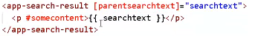

somecontent is accessed inside app-search-result using @ContentChild.

**ngAfterContentInit** is used when you want **to manipulate** the content inside the child tags (appSearchResult here)and **ngAfterContentChecked:** Invoked whenever the content of <ng-content> or child tags changes i.e. inside child component. **This is used when the content inside the child tags changes. Content change as in both the external content or the content binded using interpolation.**

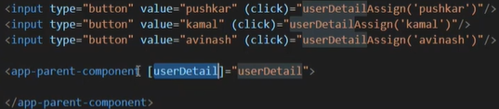

**ngAfterViewInit** is called after **ngAfterContentChecked.** This is used inside the parent. If you have some html inside template, to catch hold of that, we make use of **ngAfterViewChecked.**

The child class, view Init will be called after the template of it is loaded and for parent class, when its template and the template of child class is loaded completely.

**ngDoCheck, ngAfterContentChecked, ngAfterViewChecked --- > Very costly since these 3 are called always when there is a change and hence hits the performance.**

**See the video -------- >** <https://www.youtube.com/watch?v=CXJunAI6yGk>

**OBSERVABLES:**

Not a part of angular. It is a concept used in angular. It is a part of RXJS (Reactive Extensions for JavaScript) library.

Difference between Promise and Observable.

Observable is a stream of data which can be observed. When data arrives in a stream, the application is notified. App subscribes to the observable to get the result. After it is notified, the job is not done for observable but incase of promise which is subscribed, the job is done once it notifies the subscriber. If some more data comes, observable notifies again but promise does not. Once the observable gets an error, it stops notifying.

Also, you can unsubscribe an observable but not a promise.

There is subscriber and observer. The observable is not concerned from where the data comes.

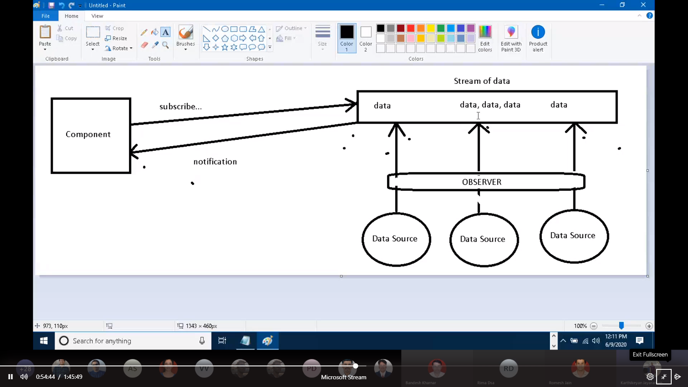

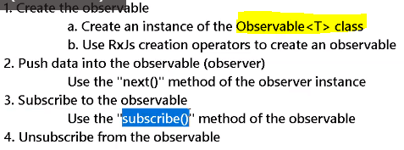 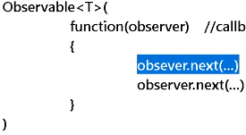

The observable constructor **takes a function as an argument** which has observer as an argument.

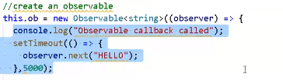 for error, observer.error(“ABC”);

**Observables are lazy loaded**. Only when one subscribes using the subscribes method, the function callback is called.

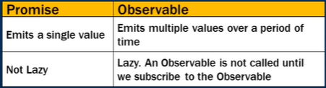

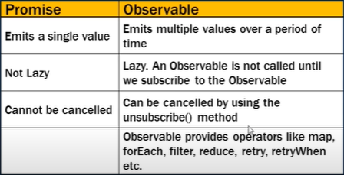

Subscribe () has 3 parameter, success, error and completion callback. After calling completion callback, stream has to be closed i.e. we cannot receive or push data into the observable. After error call back is called, the stream/observables itself is closes.

RXJS operators are used to create (of / from) and also manipulate the observable (map / filter).

Of () ------- > creates observable from a **comma separated list**

From () ----------- > creates observable from an **array**

RXJS operators: <https://www.learnrxjs.io/>

Subscribing to an observable returns a subscription object. We need this object to unsubscribe in ngOnDestroy. Ex: **this.subscription = this.obs.subscribe(….);**

This is the old method. New method is to use a **takeUntill** operator.

In Angular we can subscribe to an observable in two ways:

**Manner 1:**  
We subscribe to an observable in our template using the async pipe. The benefit of this is that Angular deals with your subscription during the lifecycle of a component. Angular will automatically subscribe and unsubscribe for you. Don’t forget to import the “CommonModule” into your module, as the async pipe will be exposed from that.

Please note the dollar sign. Using the dollar sign in the name of a variable that is an observable, is considered best practice. This way it’s easy to identify if your variable is an observable or not.

**Manner 2:**  
We subscribe to the observable ourselves using the actual subscribe() method.

Calls of the next are the most common as they actually deliver the data to its subscribers. During observable execution there can be an infinite call to the observer.next(), however when observer.error() or observer.complete() is called, the execution stops and no more data will be delivered to the subscribers.

When you subscribe to an observable, you get back a subscription, which represents the ongoing execution. Just call unsubscribe()to cancel the execution.

Observables use a unicast pattern. Every subscriber has a separate stream in which data is pushed.

Same stream for all subscriber ----- > **Multicasting**

**Operators**: Each operator returns a function.

The function can then be combined with the observable.

Call the function passing the source observable.

Pipe () is used to combine multiple operators. Call this function in observable. Call this on source observable.

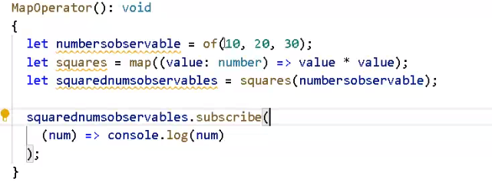

Map operator will return a function and this function has to be called passing the observable.

We can also do this inside the subscribe function instead of using operators.

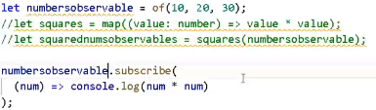

**Why operators:**

Before you subscribe to an observable, filter it and get it instead of getting all the data/list and then filtering it inside the subscribe function.

So, generally they are used in services which get the data using http which returns a observable and the list is transformed if needed.

**ASYNC PIPE**: Automatically subscribes to an observable from within the template

It automatically also unsubscribes from the observable when the value emission is complete.

Usage: ---- > **{{source observable | async}}**

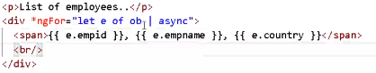

Ob is the observable here. It should be an array to apply ngFor.

**HTTP Communication**:

**HttpClientModule**

**HttpClient**- Has various methods. These methods return back an observable.

Get (), Put (), Delete (), Post (), Patch (). These methods internally are written to return an observable. The API itself has code for the observable. You do not have to create one. You only need to subscribe to it. These methods are written in service where REST calls are made. This is done for separation of concerns. We can also do REST calls from a component.

So, service is the right place to use operators. Objective should be service has to return back an observable and not data. Inside service you invoke the methods of HTTP Client.

JSON-SERVER: allows us to create REST API using a json file. Observables are present on client side and not server. Runs on port 3000.

Command to check if json server is there or not --------- > json-server

Make a file and run the command after entering into the directory of the file.

One of the strong features of **HttpClient** service is that you can have a strongly typed response. You can tell the methods (get/post/put) what kind of response you want.

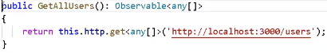

Handling Errors: Error occurs when

1. When the request fails

Error Event Object

1. When there is an error response

HttpClient returns an error object. One way to handle it is inside the subscription and other is to handle it in service itself.

For any type of error response, the return value is HttpErrorResponse.

It is better to handle it in service.

**The handler returns an RXJS ErrorObservable with a user-friendly error message. The following code updates the getConfig () method, using a**[**pipe**](https://angular.io/guide/pipes)**to send all observables returned by the**[**HttpClient.Get()**](https://angular.io/api/common/http/HttpClient#get)**call to the error handler.**

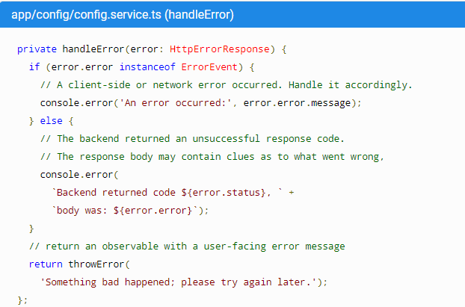

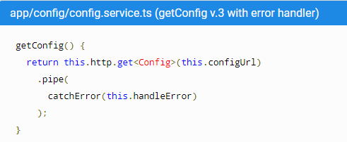

**Routing:**

Technique to navigate In Single Page application.

Navigation actually takes place between components but it is seen as if it is done between pages.

Navigation logic is not client side and not on server side. In traditional framework, logic is on server-side ASP Framework, .NET etc

1. Import **Router Module** (contains the no of classes implementing routing) inside **Root Module**

Router outlet shows components made through routing.

We also have nested router-outlet inside component.

Routing mechanism works by checking the URL and then taking some decision.

1. Create a **route configuration**.

Can be created at many levels.

Generated at **ROOT route configuration (normally app.routes.ts used)**

If feature module present **– Module Route Configuration**

All module config will get merged into ROOT by angular. Angular will see it as one big root config.

1. Place a <router-outlet> in the root component’s HTML
2. Create router links for the user to navigate

Route ----- > The URL pattern

The component

Children

Routing guard to load

**ROOT route configuration has to be made available to Root Module. Configuration is written in appRoutes. It is made available by using forRoot () which takes this configuration as an argument and export a RouterModule with all the routing services injected inside it. So, app module has to import this RouterModule routes.ts**

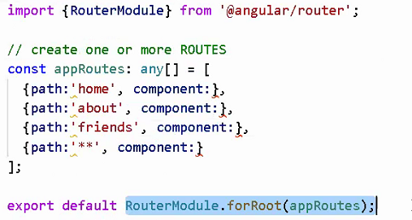

**This is the root route configuration.**

We can also do it in app module and no need of app routes. But it is a good practice to keep it separate.

If done in app module, in import write RouterModule.forRoot(appRoutes);

**http:localhost: 4200 or http:localhost: 4200/index.html ----- > Root Component is loaded**

**http:localhost: 4200/index.html/home --- > Pattern matching begins from /home i.e. after index.html**

**{path: “”, component: HomeComponent) -------- > Both Redirect to a default Component**

**{path: “”, redirectTo: ‘home’, pathMatch: ‘full’)**

**------------------------------ > Star is always kept at the bottom < -------------------------------**

All these components are put in the router-outlet on demand. We do not need to put the selectors of these components inside the app html.

**Navigation Links:**

<a routerLink=”/home” >Home</a>

It is going to create a hyperlink. Router Link is angular specific.

If a component takes a parameter

**{path: “search/:id”, component: SearchComponent)**

Read route parameters inside component: use **Activated Route service (@angular/router)**

Use params property. We can also subscribe to it.

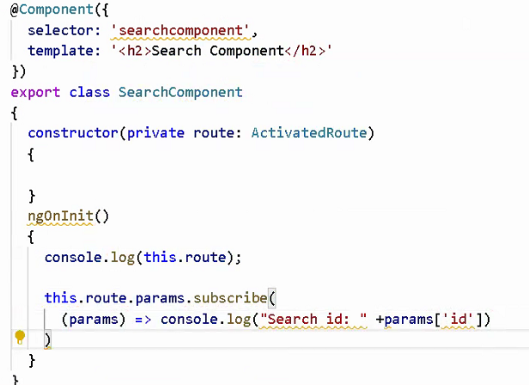

For imperative routing use **Routing Service**. i.e. on button click etc …

We do **router.navigate([/home]); ----- >** you specify path inside array

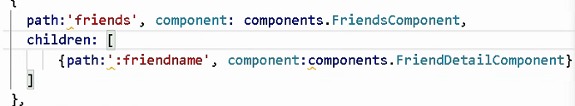

For children we do not need to start with ‘/’;

In the parent template, we have to add <router-outlet> for the loading the child components.

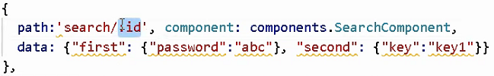

This data property information is not passed in the URL. The component who has to read this subscribes it. this.route.data.subscribe();

**Angular forms:** HTML template ----------> used to capture information

Typescript code ------- >Process the information

Angular Service ------- > Sent to the server

Both have form models. Difference is how you access the models.

1. **Template Driven**

The entire form setup is done in the html template.

Angular directives are used to link input controls to the “form model”.

This is used when form is **simple** and consists of **fewer number of controls**.

Validation and all are done inside template.

Drawbacks: This cannot be unit tested since entire thing is done is template.

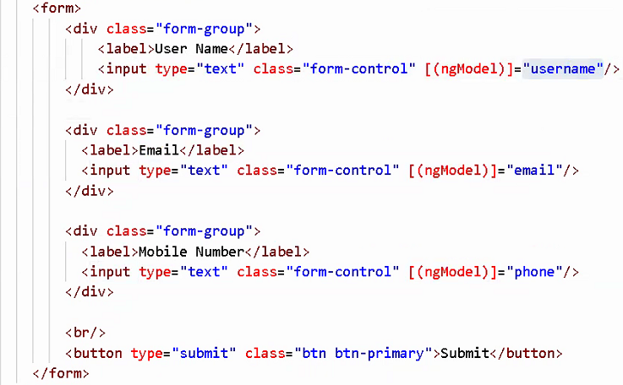

**CSS classes**:

--------- >TRUE <----------------------------------- > FALSE < -------------------------------

**ng-touched ng-untouched** ---------> if controls gets focus or not

**ng-dirty ng-pristine** ---------> if controls is changed or not

**ng-valid ng-invalid** ---------> if controls is valid or not

Using these CSS classes, we can track the form control. Angular applies a directive **ngForm** automatically to the form.

Instead of you remembering these classes, ngModel gives them as a property. It has also got an error property.

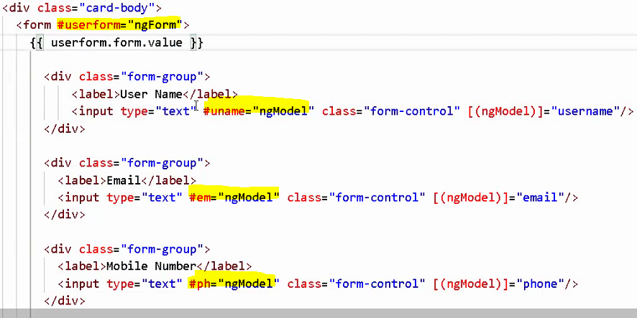

Also set a name property which can be set to anything. Since it is stored in form of object, we have to set the name as it is taken as a key name for the object properties.

We can track state or form or individual controls using --- > ph.valid / em.dirty / userform.value / userform.pristine

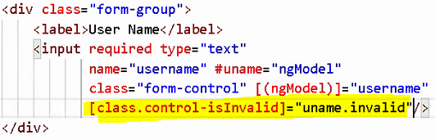

Apply CSS class if the control is invalid.

Multiple errors:

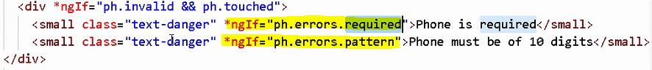

Angular creates form control on its own. Angular forms API is used behind.

Form control class is only way to interact with DOM element.

Left side can be anything. But behind FormControl class is used.

Reactive form has direct access to FormControl class but in template driven forms, we need ngModel directive (which acts as a type of layer of abstraction here). But FormControl is used in both.

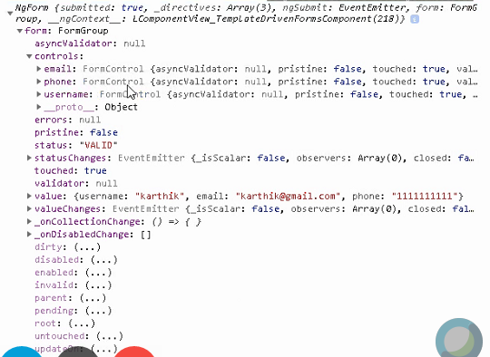

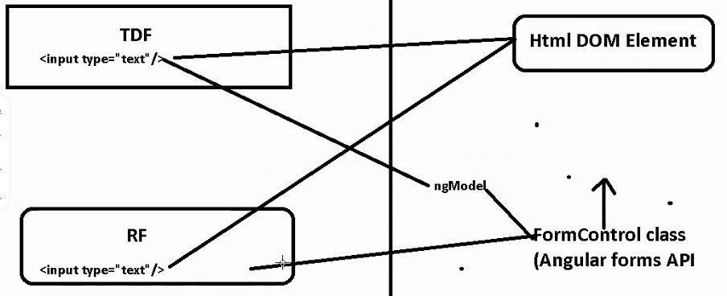

**How FormControl interacts**:

There is one more layer --- > ControlValueAccessor which is an interface implemented by directives such as ngModel. It is basically a bridge between DOM and FormControl. If there is any change in input element or Dom element, it will be taken by **ControlValueAccessor** and it will be passed to FormControl. When you make changes to FormControl, **ControlValueAccessor** takes the changes via ngModel and passed it to DOM element. 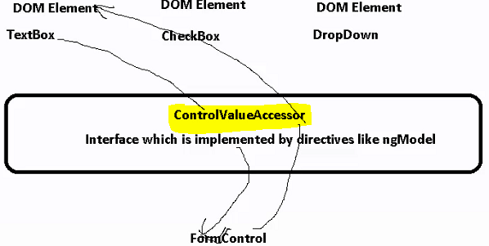

There are different ControlValueAccessor for different input elements.

If you want to create a custom directive for FormControl, you can implement ControlValueAccessor.

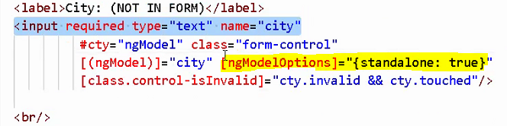

Though it has a name attribute, it will not be a part of the form. We know that name attribute is necessary for a control to be part of the form.

It will not be available in the **userform.value**

1. **Reactive or Model Driven Forms**

Used if want to do custom validations

Used in forms where complexity is more.

1. Import the ReactiveFormsModule in App module.

**FormGroup**

**FormControl**

**[formControl]**

**[formControlName]**

**[formGroup]**

**[formGroupName]**

1. Create one or more instances of FormControl and bind them to DOM elements using the above directives.
2. Import FormGroup and FormControl classes from @angular/forms.

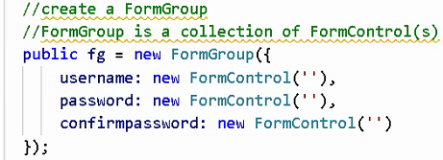

1. Create a form in template and link it with form in ts file.

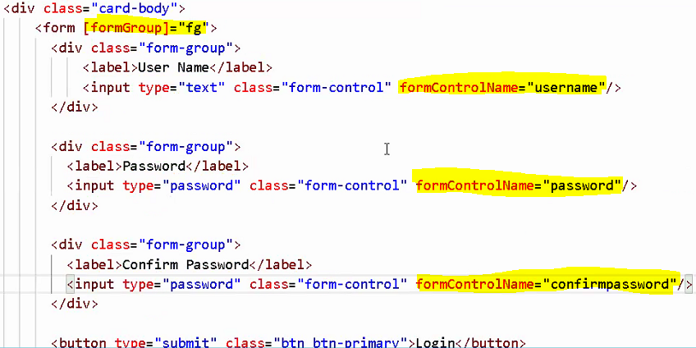

You can create formGroup by 2 methods-------- > by FormGroup or **FormBuilder** which internally contains a collection of FormControl.

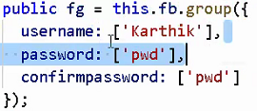 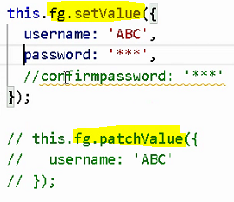

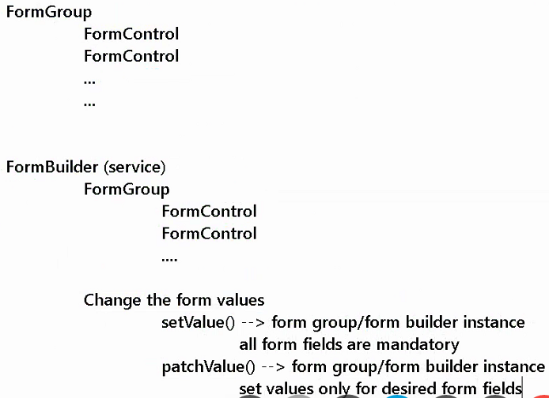

ControlValueAccessor places a important role here too. We also have getValue ()



**Validations**: Can be performed at two levels –

1. FormControl Level
2. FormGroup level --------- ex for password and confirm password

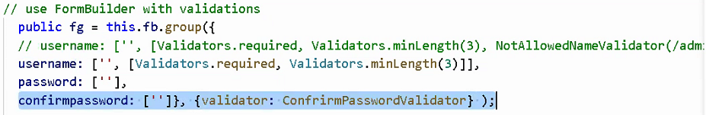

Custom Validator: Steps --- >

1. Create a function (Factory Function)
2. The function must return a “ValidatorFn” (Interface in Angular) which accepts an “**AbstractControl**” as an argument (FormControl or FormGroup) and returns a key/value dictionary if the validation fails, if the validation passes, it must return null (because signature if function inside interface has been defined in such a way)

Not necessary to pass RegExp. It makes it easy by using it.

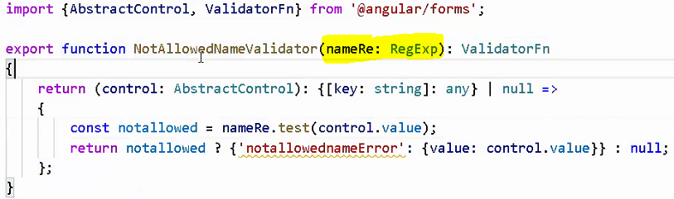

For errors display -------- > .value should be used here o change the value property to errormessage above.



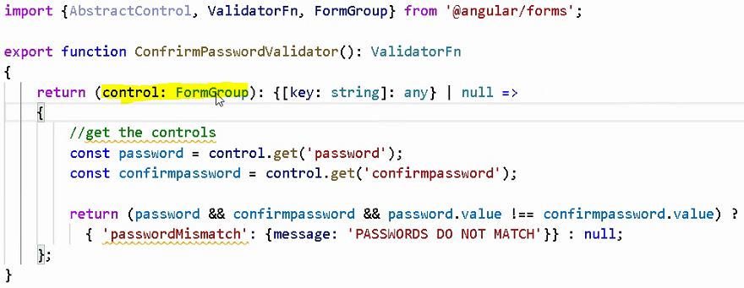

We can either use FormGroup / AbstractControl since FormGroup extends AbstractControl

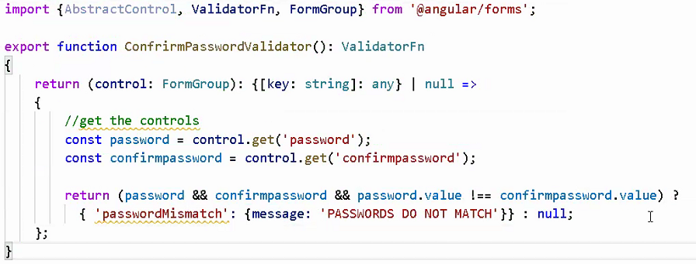

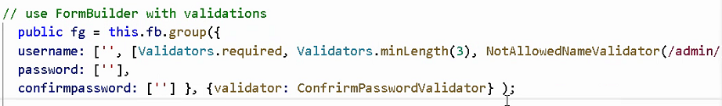

For errors we will not use get () and directly use errors since we are applying it on group level

**AOT vs JIT:**

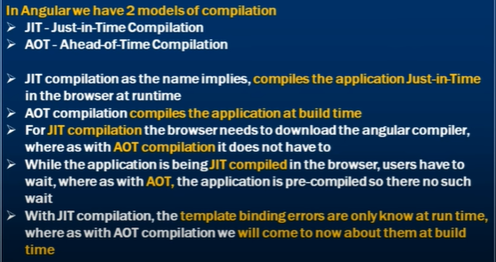

**RXJS:**

Observables are always unicast in nature. Every subscription will create a different stream.

**asObservable** makes the original subject inaccessible for subscribers. This way you can limit who can only subscribe and who can also emit values.

Unsubscribing observables”

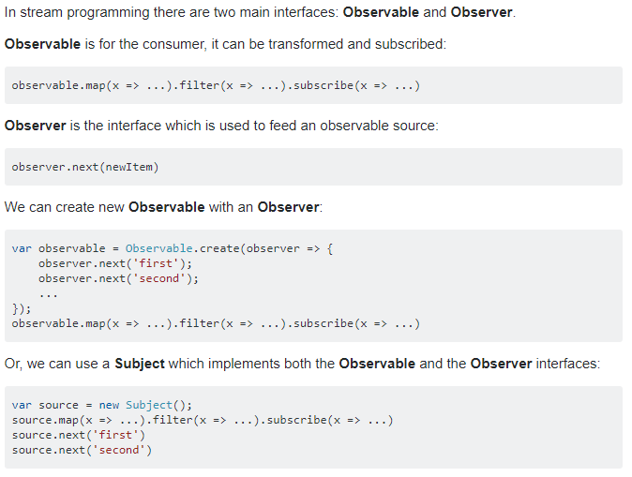

Only observer can push data into observer. So, we can make use of Subjects or behavior subject.

We can push data, subscribe and unsubscribe to it directly.

publicbehaviourSubject: BehaviorSubject<boolean> = newBehaviorSubject<boolean>(false);

**OR**

​public behaviourSubject = new BehaviorSubject<boolean>(false);

A Subject is like an Observable, but can multicast to many Observers. Subjects are like EventEmitters: they maintain a registry of many listeners.

**Observables**

1. They are cold: Code gets executed when they have at least a single observer.
2. Creates copy of data: Observable creates copy of data for each observer.
3. Uni-directional: Observer can not assign value to observable(origin/master).
4. The code will run for each observer . If its a HTTP call, it gets called for each observer.
5. if its a service we want to share among all the components, it wont have latest result all new subscribers will still subscribe to same observable and get value from scratch
6. Unicast means can emit values from the observable not from any other component.

**Subject**

1. They are hot: code gets executed and value gets broadcast even if there is no observer.
2. Shares data: Same data get shared between all observers.
3. bi-directional: Observer can assign value to observable(origin/master).
4. If are using using subject then you miss all the values that are broadcast before creation of observer. So here comes Replay Subject
5. multicast, can cast values to multiple subscribers and can act as both subscribers and emitter

**You can Communicate Between Components with Observable & Subject**

Create a BehaviourSubject or Subject in a service and use it in other components.

Use next to push data and subscribe to get it.

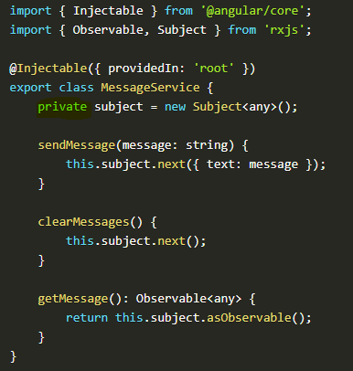

Since the subject is private here, we can create getters and setters and make them available.

asObservable returns an observable.

An observable can be created from both Subject and BehaviorSubject using

subject.asObservable().

BehaviorSubject : Upon subscription, it returns the last value of the subject. A regular observable only triggers when it receives an nex().

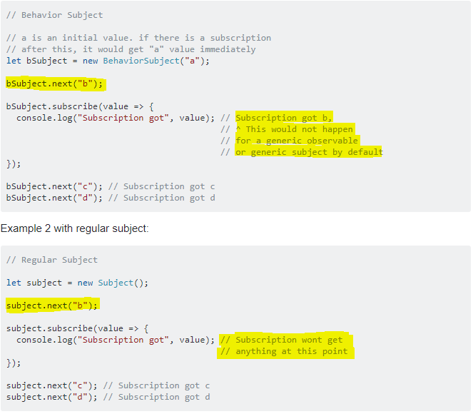

We know that observables are unicast. They create a separate stream for every observer and subject shares a common stream to all the observables. This is because subject creates an array of observers (observer for each subscriber) and forwards them the data and Subject in turn has to subscribe to an observable.

**Probably a more important distinction between Subject and Observable is that a Subject has state, it keeps a list of observers. On the other hand, an**[**Observable is really just a function**](https://medium.com/@benlesh/learning-observable-by-building-observable-d5da57405d87)**that sets up observation.**

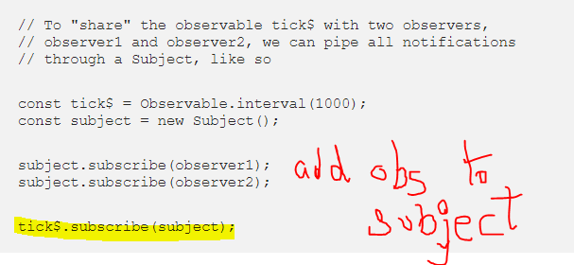

<https://medium.com/@benlesh/on-the-subject-of-subjects-in-rxjs-2b08b7198b93#:~:text=Probably%20a%20more%20important%20distinction,also%20implement%20an%20Observer%20interface.>

<https://medium.com/@luukgruijs/understanding-creating-and-subscribing-to-observables-in-angular-426dbf0b04a3>

Unsubscribing a subscription: When you subscribe to an observable, it returns a Subscription. You can either create a subscription object and and assign it the subscribed object or use take family operators. This operator takes a subject as an argument having a default value false. When this subject is pushed a value true, the observable stops receiving value.

**takeUntil(notifier)** : This operator emits values emitted by the source Observable until a notifier Observable emits a value.

<https://blog.bitsrc.io/6-ways-to-unsubscribe-from-observables-in-angular-ab912819a78f#:~:text=Use%20the%20unsubscribe%20method,unsubscribe%20method%20in%20the%20Observable.>

There is no need to unsubscribe for the observables that come from the HttpClient data providing methods (i.e.. .get()) as those observables are **finite.**

A **finite observable** is the one that **completes**.That means that after emitting the first value of such observable, it gets automatically closed, and a complete method will be called.

<https://medium.com/@garfunkel61/unsubscribing-from-angular-httpclient-data-requests-observables-44fc5a4965d5>

**Angular Documentation**

**Multiple Structural Directives inside same element**

Angular does not allow this. But you can use <ng-container> for this.

The Angular **<ng-container>** is a grouping element that doesn't interfere with styles or layout because Angular doesn't put it in the DOM. You can use multiple nested containers each having a structural directive.

**@ViewChildern:**

Use to get the Query List of elements or directives from the view DOM. Any time a child element is added, removed, or moved, the query list will be updated, and the changes observable of the query list will emit a new value.

View queries are set before the ngAfterViewInit callback is called.

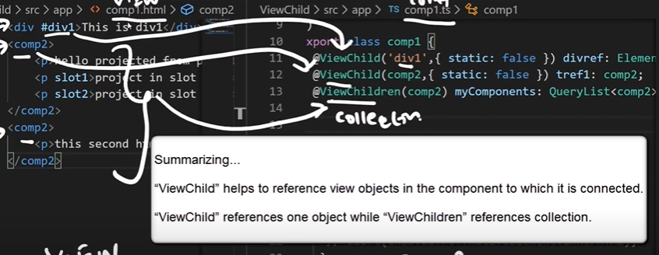

ViewChild references one object => we can access not only template reference variable but also a component, Custom directive. We have to just set the desired type of the variable.

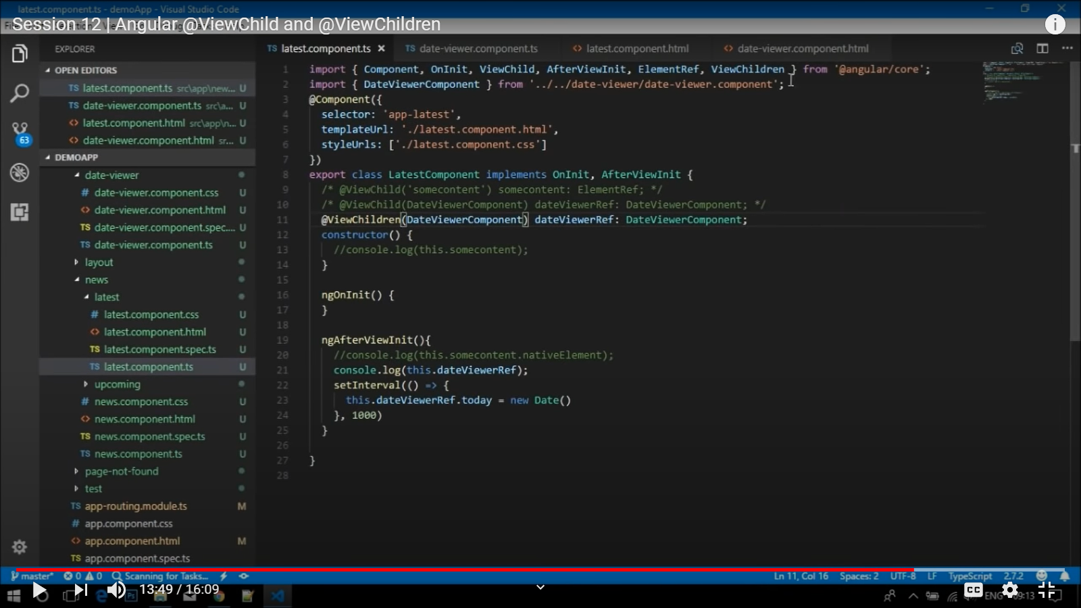

<https://medium.com/@kevinwkds/angular-views-and-references-element-template-viewcontainer-5cdcf6b21bdb>

<https://indepth.dev/exploring-angular-dom-manipulation-techniques-using-viewcontainerref/>

# **Angular Change Detection Strategy**

ngTemplateOutlet

Guards:

Route guard: Controls navigation to and from components

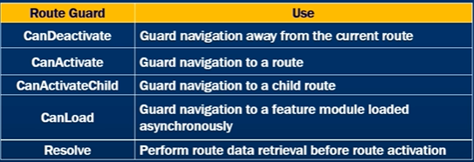

Three steps to build a route guard:

1. Build the guard
2. Register the guard with angular DI
3. Tie the guard to the route

A guard is implemented as a service. It is nothing but a class. Each guard has its own interface<T>.

The method of interface can return an observable, promise or a Boolean value.





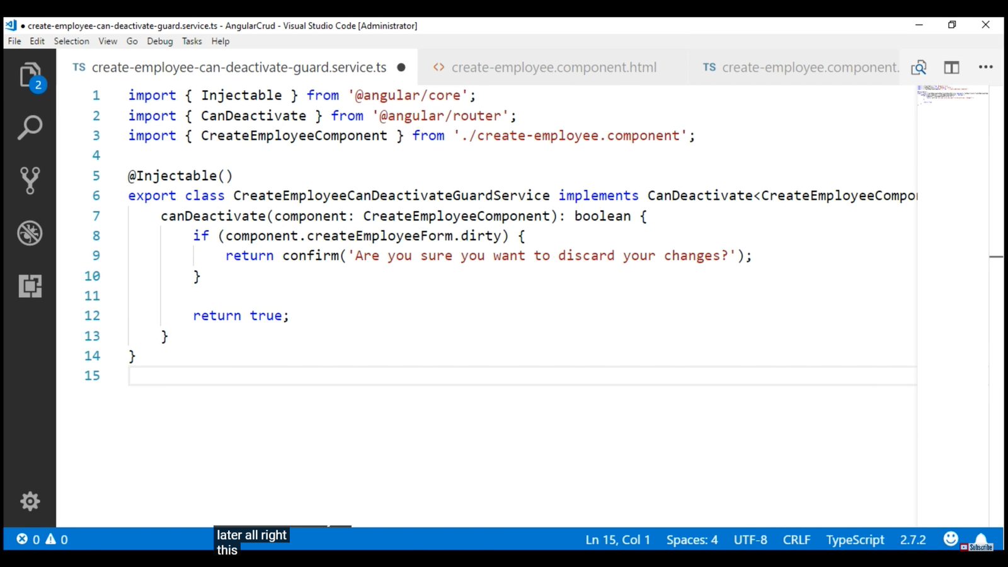

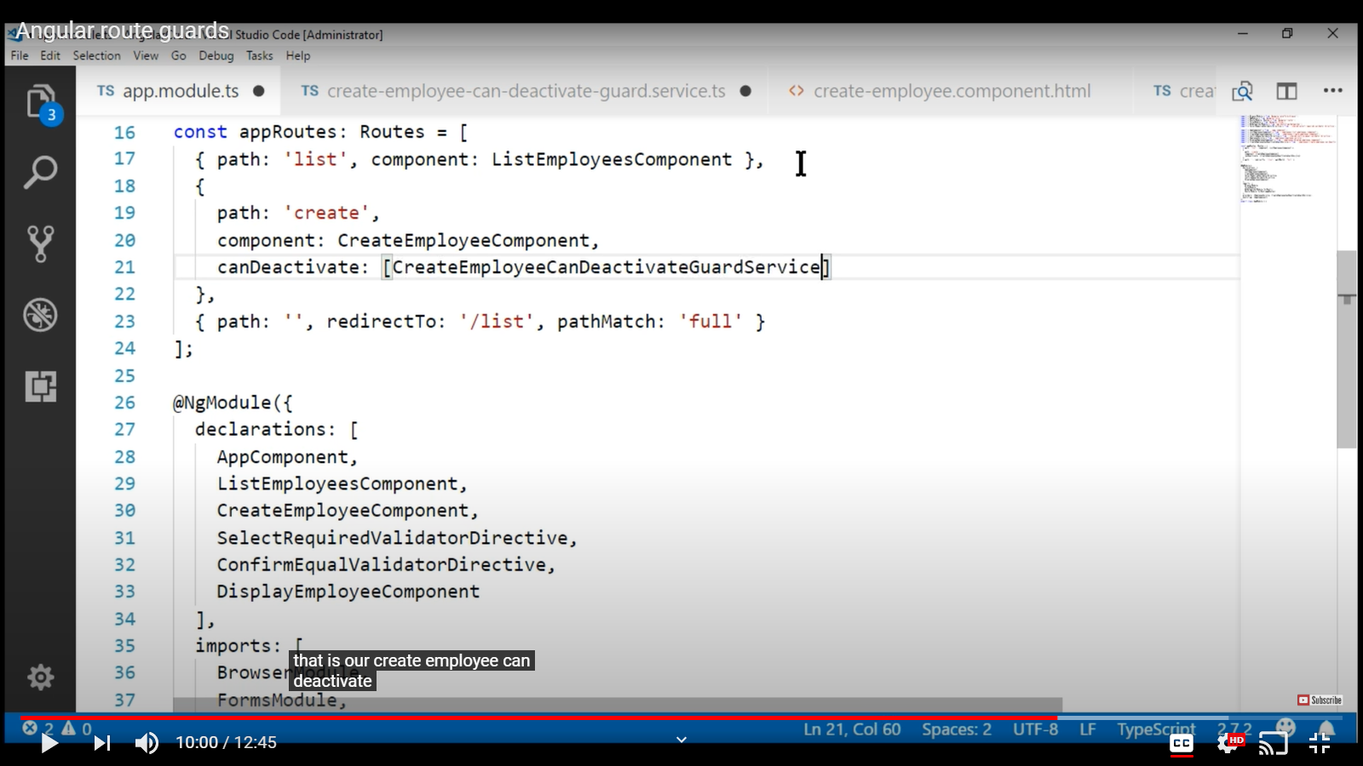

Use the **canDeactivate** property in routes.

Can activate:

Use Case: If user is authenticated to use a component or not

Check if a resource he is checking for exists or not.

When we want confirm if a user having Id given in URL exists.

Open a component/view after checking a value or resource.

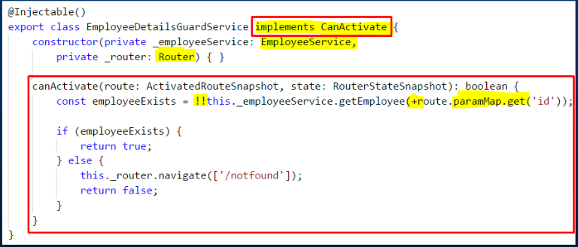

Route.paramMap.get() will return a String. So, to convert to integer we use “+”.

getEmployee will return an employee. To convert to Boolean, we use “!!”

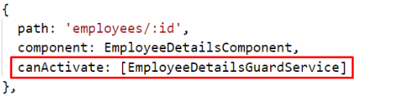

**Angular Resolve Guard**:

When we route to a component, part of page loads first and then when the data is available, it gets loaded.

* Host Element = > The element on which a directive is applied.

HostListener => This is used to listen to all the events of HostElement.

<https://www.youtube.com/watch?v=s9NqICibhIc>

Using

* To install jQuery in angular

npm install jquery –save

"scripts": [

"node_modules/jquery/dist/jquery.min.js"

]

Add the reference in scripts array of Angular.json

**Renderer2 class**

Renderer is mostly used in directives or places where we want to change the DOM behavior on an event. (Ex- tooltip, change color on mouse hover or click…)

To modify or manipulate a DOM element.

<https://www.concretepage.com/angular-2/angular-4-renderer2-example#setProperty>

ElementRef simply wraps the native DOM element, and we can retrieve it by accessing the nativeElement property.

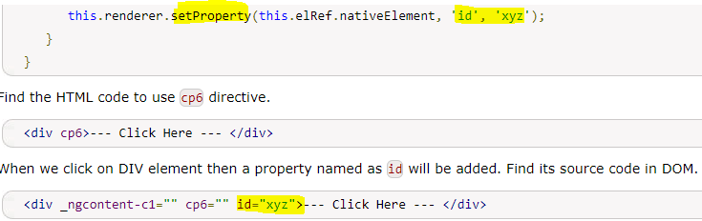

Other Properties:

[1. createElement(), createText(), appendChild()](https://www.concretepage.com/angular-2/angular-4-renderer2-example#appendChild)

[2. insertBefore()](https://www.concretepage.com/angular-2/angular-4-renderer2-example#insertBefore)

[3. removeChild()](https://www.concretepage.com/angular-2/angular-4-renderer2-example#removeChild)

[4. selectRootElement()](https://www.concretepage.com/angular-2/angular-4-renderer2-example#selectRootElement)

[5. setAttribute() and removeAttribute()](https://www.concretepage.com/angular-2/angular-4-renderer2-example#setAttribute)

[6. setProperty()](https://www.concretepage.com/angular-2/angular-4-renderer2-example#setProperty)

[7. addClass() and removeClass()](https://www.concretepage.com/angular-2/angular-4-renderer2-example#addClass)

[8. setStyle() and removeStyle()](https://www.concretepage.com/angular-2/angular-4-renderer2-example#setStyle)

[9. parentNode()](https://www.concretepage.com/angular-2/angular-4-renderer2-example#parentNode)

[10. createComment()](https://www.concretepage.com/angular-2/angular-4-renderer2-example#createComment)

[11. listen()](https://www.concretepage.com/angular-2/angular-4-renderer2-example#listen)

The difference between attribute and property of a HTML element is that attributes are defined by HTML and properties are defined by DOM.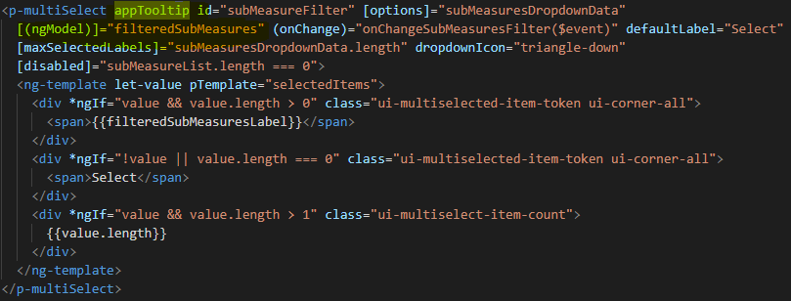

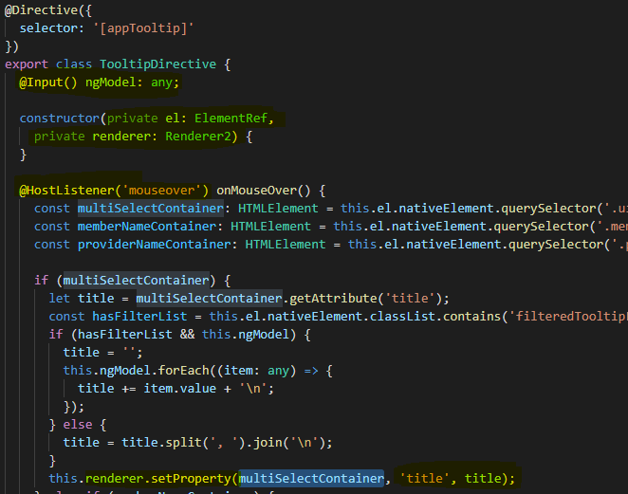

**Deep copy vs Shallow Copy**

In JavaScript, you deal with pass value by reference unless you deal with primitives.

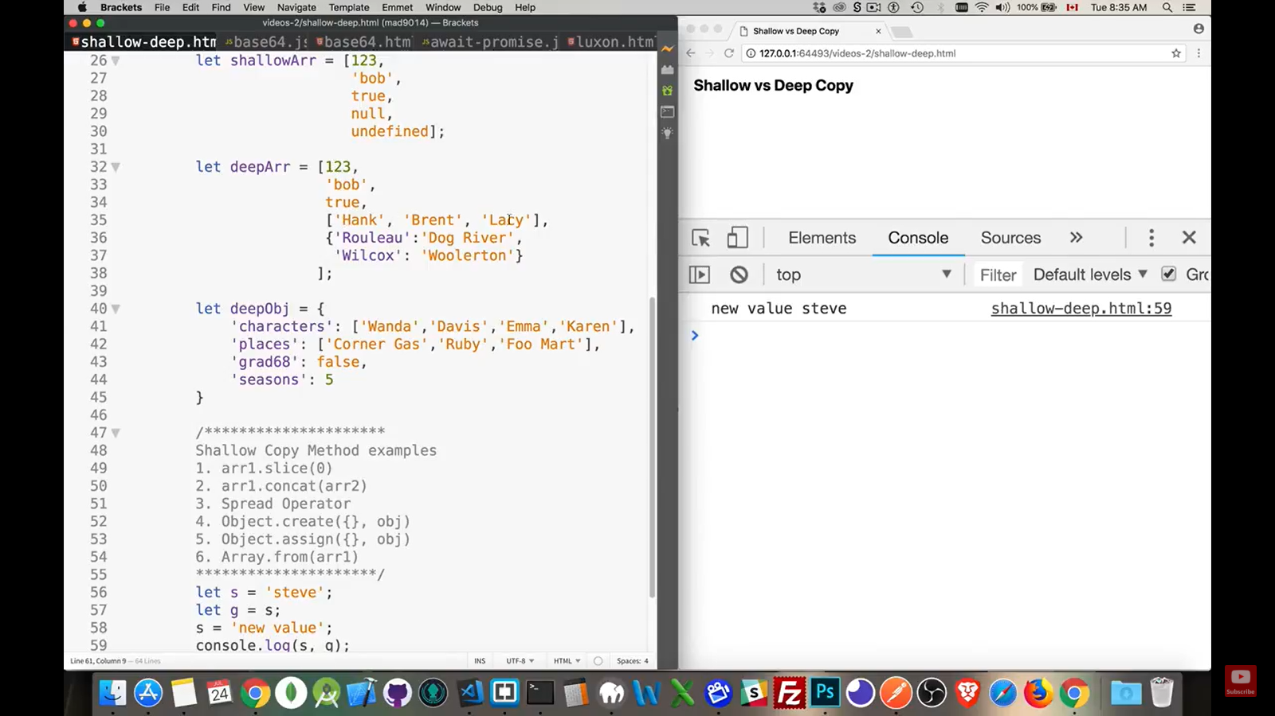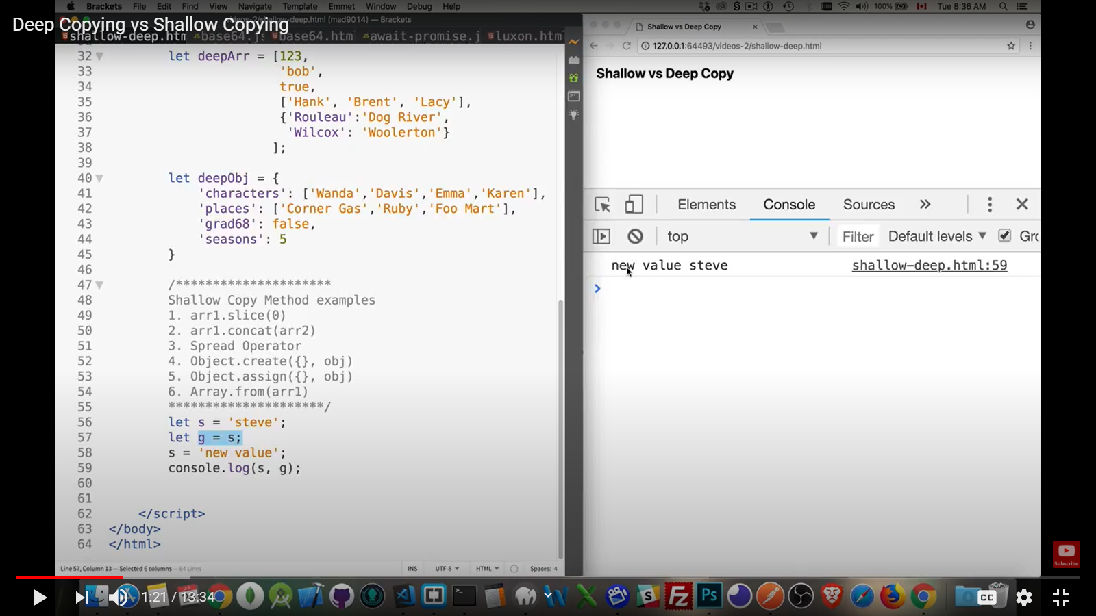

In above example, g is copied a value and not reference. So, if change is made in ‘s’, it will not be reflected in s.

But if one object is assigned to other, it is set as a reference. So, if change is made in the initial object, it will reflect in the assigned object or vice versa.

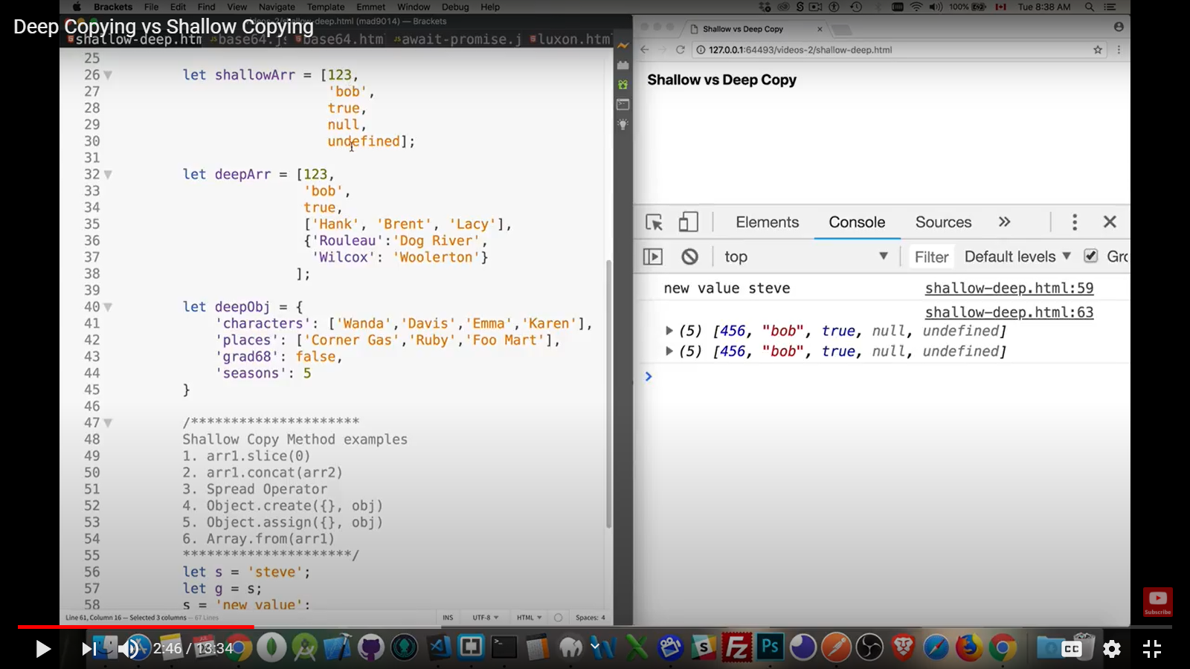

So, if we want to create a whole new copy of the array / object, we use the above methods.

But these methods will do a shallow copy. Means it will create a new copy for elements which are primitive as shown in shallowArr and assigns a reference to the non-primitive elements as shown in deepArr (at position 3 and 4).

So, any change made to new array will reflect in old one. So, we use deepClone or Json.parse ()

A common use of JSON is to exchange data to/from a web server.

When sending data to a web server, the data has to be a string.

Convert a JavaScript object into a string with JSON.stringify().

When receiving data from a web server, the data is always a string.

Parse the data with JSON.parse(), and the data becomes a JavaScript object.

Clone Deep ----- > when object contains only non-primitive values also

Shallow clone -> when only primitives are present in object





<https://www.youtube.com/watch?v=CF-T-HjImw8>

<https://www.youtube.com/watch?v=duyshh9Fs1U>

**finalize / finally**

# signature: finalize(callback: () => void

# Call a function when observable completes or errors

**CORS: Cross Origin Resource Sharing**

**Cross-Origin Resource Sharing** ([CORS](https://developer.mozilla.org/en-US/docs/Glossary/CORS)) is a mechanism that uses additional [HTTP](https://developer.mozilla.org/en-US/docs/Glossary/HTTP) headers to tell browsers to give a web application running at one [origin](https://developer.mozilla.org/en-US/docs/Glossary/origin), access to selected resources from a different origin.

<https://developer.mozilla.org/en-US/docs/Web/HTTP/CORS>

**@View Child:**

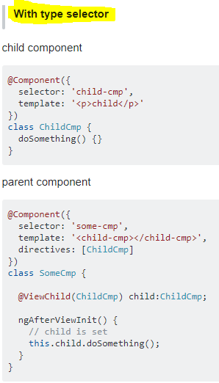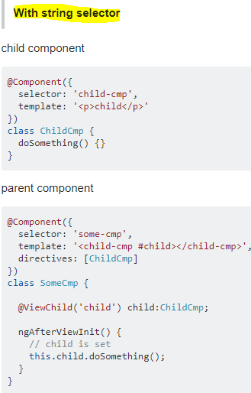

Web Component: It is a framework independent component. A component that is written I none framework and can be reused in another framework.

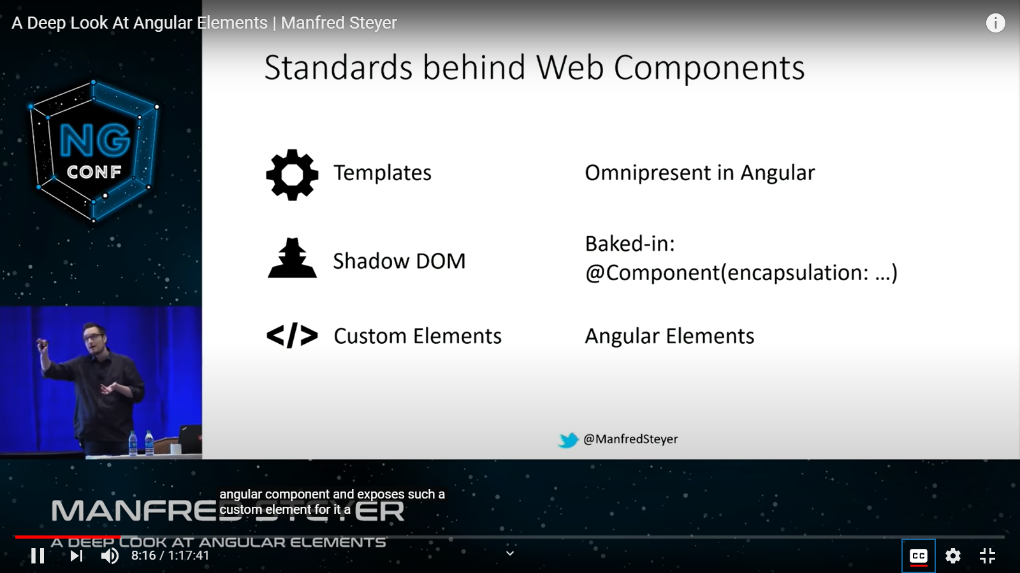

This custom element is added in the Entry Component since it is dynamically created.

The wrapping code can be placed in Main.ts or component or service or module. You also need to pass injector inside to install the DI mechanism in your component. This means the component which is passed as element can make use of other services by means of injection.

**Styles.scss** ----- > Here you can define *global CSS* and also can import other custom CSS files which may be defined in assets folder.

**package.json** & **package-lock.json** are present in the root directory itself.

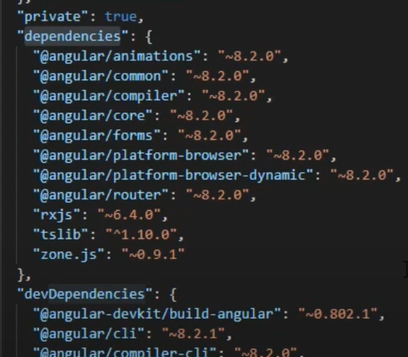

npm install or npm update --- > install all the dependencies present in package.json. **dependencies** are the one which are required during the production and goes with it while **devDependencies** are the one which are required during the development time. ex: cli which is required only during dev time which converts typescript to browser understandable code i.e. it acts as an interpreter.

RxJS is a third-party library that helps us to connect the front end to API in backend through http connections.

We can also see two types of versioning here in form of **x.y.z** and prefixed by either **~** or **^**.

X ------ > Major version

Y ------ > Minor version

Z ------ > Patch version

**Consider ~8.2.0**

**~** versioning says that install package should be equal to this (8.2.0) or a package with higher patch version i.e. **8.2.1** or **8.2.2** or **8.2.3** and so on. (X and Y should be same)

**Consider ^1.10.0**

**^** versioning says that install package with the same major && higher or same minor and patch value. i.e. keep major same (1 here) but the minor should be 10 or higher and patch should be 0 or higher.

**Package-lock.json file:**

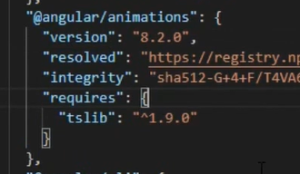

Here we see a tree structure. This file ensures that the project is **build with same version in different env** and at different times.

As we have versioning in package.json, it may happen that npm takes a latest version of a package (tslib say 1.11.0) in local and during production, the version which is set in package.json is taken (tslib 1.10.0). This will lead to different behaviors of code in local and in prod. This is the issue created by versioning in package.json file

So, package-lock.json is introduced. This will ensure that same version is taken at both local and prod side.

*Now why not to use a specific version in package.json itself & not using ~ or ^??*

This is due to nested dependencies as shown in above pic. In animations, we have requires tslib. So, we have dependencies which depend on previous dependencies (nested dependencies).

*This file will make sure not only the main package (animations) have the same versions but also nested dependencies (tslib) have the same versions.*

<https://www.youtube.com/watch?v=sKKeqiuaKpg>

<https://www.youtube.com/watch?v=H3n75nHN5qY>

So, since we are providing versions of all packages in package.json, the nested dependency will have the same version as this dependency’s main package.

If we add a package as a dev dependency and it has its own child dependencies, these will also get installed in node_modules and all those dependencies will also be included in dev dependencies.

<https://www.youtube.com/watch?v=rT_j1UgjM4k>

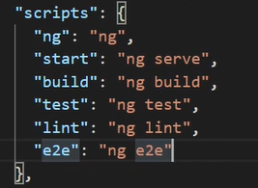

In package.json we have given the commands. To start, we do ng serve, to build we do ng build.

If node wants to do it, we can run the command ------ > **npm run start**. This will do ng serve as start refers to ng serve.

**npm install < package>**

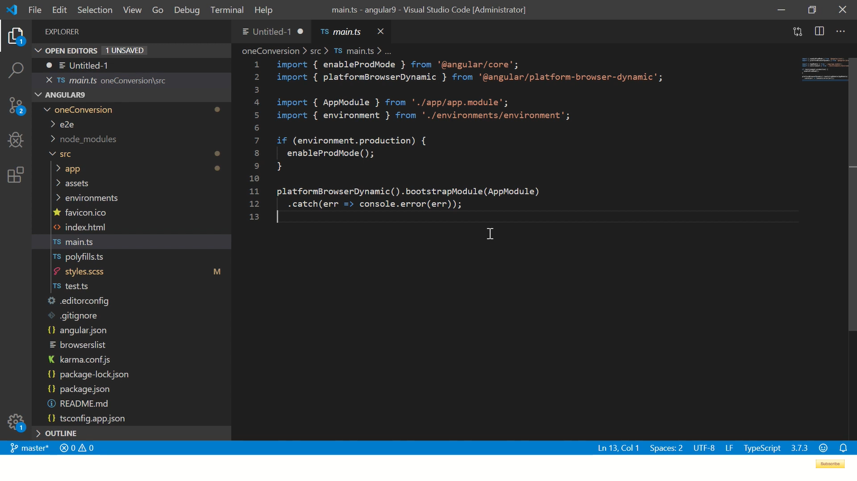

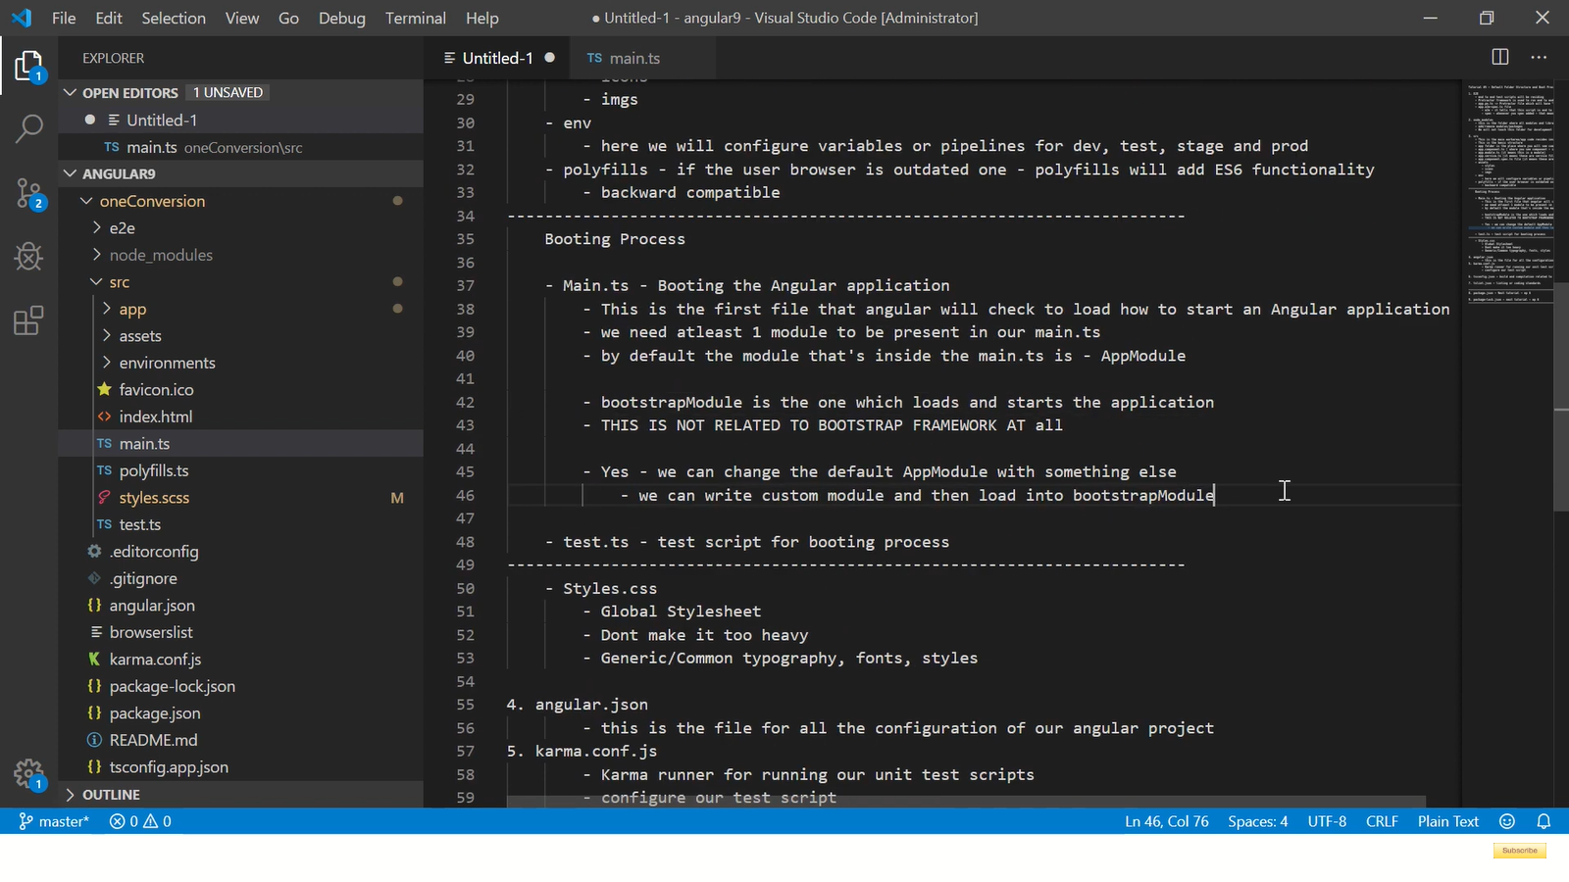

**ng new appWorkspace –createApplicaion = false**

This will only create a workspace with **no src folder** i.e. not application

To create an application in this, we do --- > **ng generate application** **< name>**

If we want a libray also, we do ---- > **ng g library <name>**

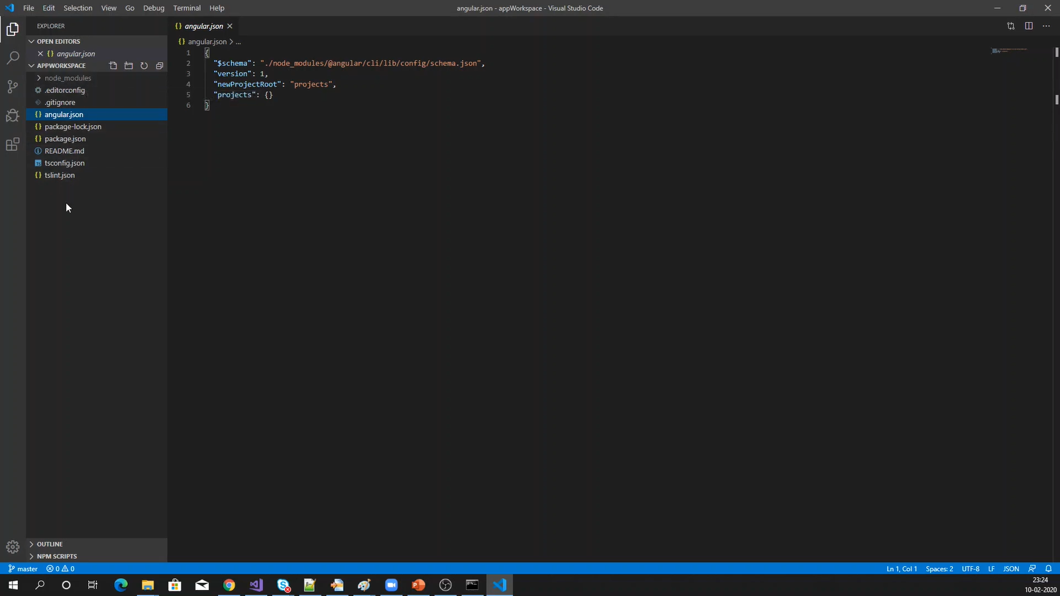

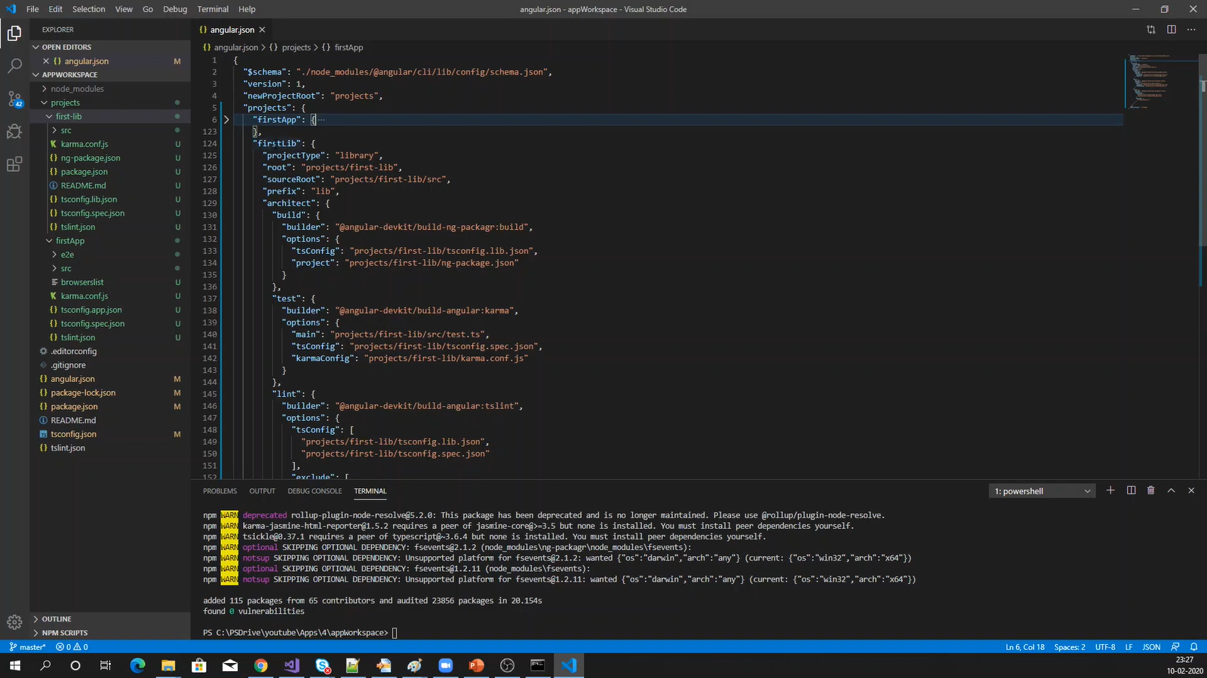

**projectType**: It is an angular application or a library

semantics: One where you can change the ng command i.e. customise the ng generate command( an ex is we can set if we want spec file to be created or not)

**prefix**: Value set to the selector of each component generated (default is app)

<https://www.youtube.com/watch?v=3DYJ72p3nUI>

**tscongif.ts**

We know browsers can only understand JS. It is the nodeJs of the CLI that converts the typescript code to JavaScript code. This conversion is done by typescript compiler and this compiler gets the configuration from this file. Basically, this file is a guide to the compiler.

There is **compilerOptions** which has a key named **target**. Its value tells the compiler to compile to the target language (ES5 here).

Also, if **sourceMap** is true, this will tell compiler to generate a .map file which is the connection between JS and TS code which is important for debugging. When you put debugger to .ts file, the .map file actually puts the debugger to the JS file.

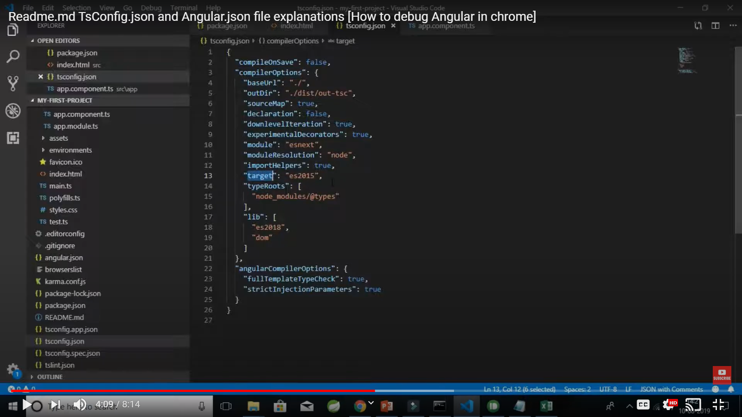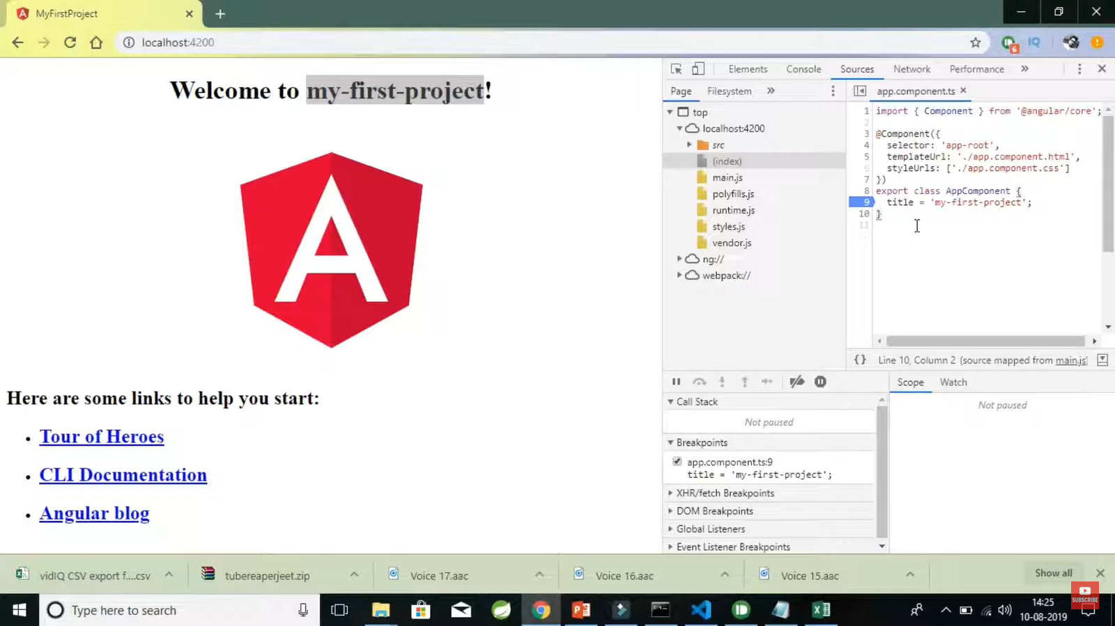

As we know, browser cannot support ts file, how are you able to debugg the ts file. This is because, when you set the sourceMap to true, a .map file is created. So, when you debugg a ts code, you are actually debugging a JS code which is seen as a ts code.

<https://www.youtube.com/watch?v=LynvU4RUSZE>

<https://dzone.com/articles/what-is-the-tsconfigjson-configuration-file>

Import a file or module => ./src or ../src

**“.”** represents the current directory and **“..”** represents the parent directory.

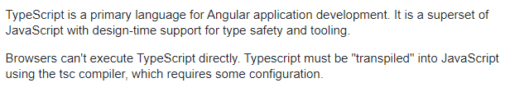

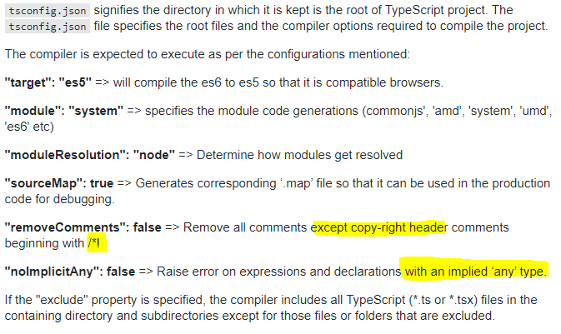

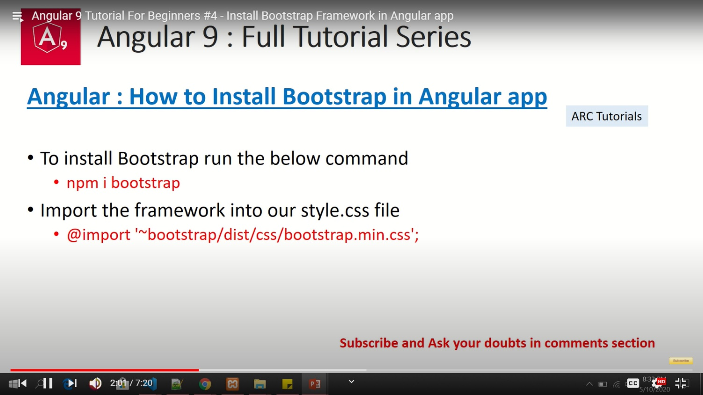

* angular-cli.json file has been renamed/replaced with **angular.json** in version 6 of Angular.
* The "assets" property of angular-cli.json can be **configured to include custom files** in angular-cli webpack build. So, configure "assets" property value as an array. For example:

**"assets": ["assets", "config.json",".htaccess"],**

* [Source maps](https://www.html5rocks.com/en/tutorials/developertools/sourcemaps/) are helpful for debugging code. You write your code in TypeScript, and the compiler turns that **source** code into JavaScript. When your app is running in a browser like Firefox, the browser is running the JavaScript. Even though the browser is running that JavaScript, if you open the debugger in Firefox, the debugger will display the TypeScript source code and will let you set break points in it. The debugger is able to do that because of source maps, which map the TypeScript source code to the JavaScript runtime code. That is what source maps do: they map the source code to the runtime code to enable source code debugging at runtime.
* When the sourceMap set to false. the output will be built without a sourceMap file. And you can't debug with the browser on ts file without that.
* Angular.json SCHEMA:<https://github.com/angular/angular-cli/wiki/angular-workspace>

<https://medium.com/@pietmichal/angulars-content-projection-trap-and-why-you-should-consider-using-template-outlet-instead-cc3c4cad87c9>

The Angular <ng-container> is a grouping element that doesn't interfere with styles or layout because Angular doesn't put it in the DOM.

**Ng-template vs ng-container**

A div or any element if set to ngIf=false, do not even get rendered in the DOM. A ng-template tag having html code also do not get rendered inside the DOM.

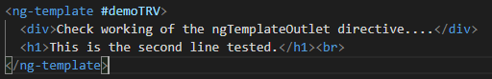

This does not get rendered

**These template elements only work in the presence of structural directives.**

<ng-template [ngIf]="visibleData" >HI !!! </ng-template>

This works property only if we have [ngIf] and not *ngIf.

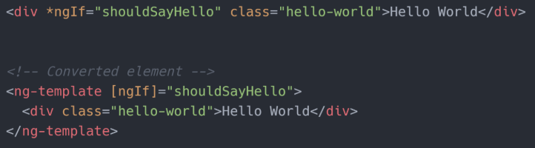

Angular wraps the host element (to which the directive is applied) inside <ng-template> and consumes the <ng-template> in the finished DOM by replacing it with diagnostic comments.

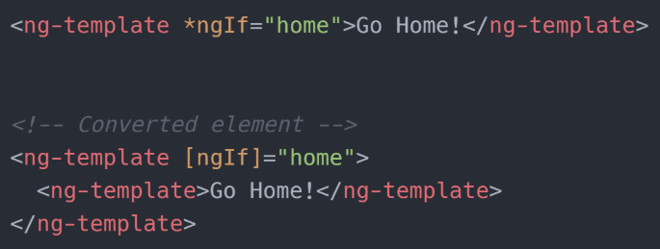

<ng-container *ngTemplateOutlet="demoTRV"></ng-container>

<ng-template *ngTemplateOutlet="demoTRV"></ng-template>

Both works same.



**ngTemplateOutlet** can be used on both elements and if used on any of the above element will render the same output.

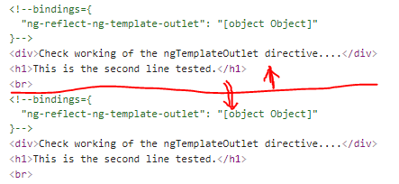

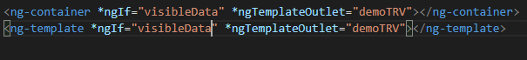

So, use one structural directive with * and it should be **ngIf**

<ng-container [ngIf]="visibleData" *ngTemplateOutlet="demoTRV"></ng-container>

<ng-template [ngIf]="visibleData" *ngTemplateOutlet="demoTRV"></ng-template>

This will always render the template having demoTRV irrespective of whether visibleData is set true or false.

<ng-container *ngIf="visibleData" [ngTemplateOutlet]="demoTRV"></ng-container>

<ng-template *ngIf="visibleData" [ngTemplateOutlet]="demoTRV"></ng-template>

Works fine and gives this. If two directives present, use * for ngIf only.

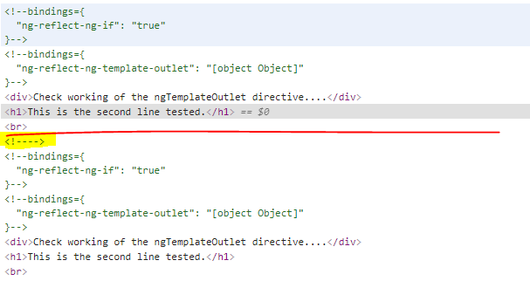

This is for the commented tag of ng-template

### *ngTemplateOutlet

1. They are used as a container to templates that can be reused at multiple places. A template or container with this directive can use the **TRV** template at multiple places.
2. There’s another use case where it is used to inject a template dynamically into a page.

We can use the above TRV only on a template and not on a normal element tag (div, p).

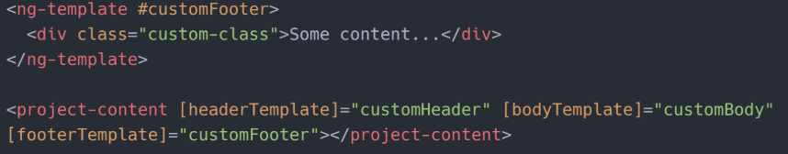



The type will be **TemplateRef**.

<https://www.freecodecamp.org/news/everything-you-need-to-know-about-ng-template-ng-content-ng-container-and-ngtemplateoutlet-4b7b51223691/>

ng-content vs. *ngTemplateOutlet

1. *ngTemplateOutlet gives us some more power of showing the default template if none is provided. This is not the case with ng-content. It renders the content as is. At the maximum you can split the content and render them at different locations of your view with the help of select attribute. You cannot conditionally render the content within ng-content
2. Also, if a component is passed inside the ng-content it gets initialized where it is passed whereas ngTemplateOutlet will initialize it when required. Even though condition is present in ng-content, component is initialized prior.

**<template *ngIf="display" [ngTemplateOutlet]="templateRef">  
</template>**

<ng-content *ngIf="display"></ng-content>

<https://medium.com/@pietmichal/angulars-content-projection-trap-and-why-you-should-consider-using-template-outlet-instead-cc3c4cad87c9>

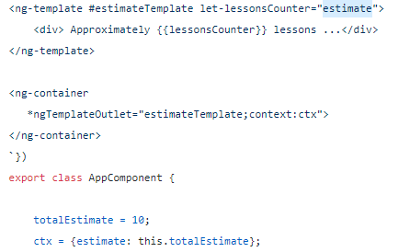

But each template can also define its own set of input variables

<https://blog.angular-university.io/angular-ng-template-ng-container-ngtemplateoutlet/>

* this template, unlike the previous templates also has one input variable (it could also have several)
* the input variable is called lessonsCounter, and it's defined via a ng-template property using the prefix let-
* The variable lessonsCounter is visible inside the ng-template body, but not outside
* the content of this variable is determined by the expression that it assigned to the property let-lessonsCounter
* That expression is evaluated against a context object, passed to ngTemplateOutlet together with the template to instantiate
* This context object must then have a property named estimate, for any value to be displayed inside the template
* the context object is passed to ngTemplateOutlet via the context property, that can receive any expression that evaluates to an object

**The entryComponents array**

An entry component is any component that Angular loads imperatively, (which means you’re not referencing it in the template), by type. You specify an entry component by bootstrapping it in an NgModule, or including it in a routing definition.

There are two main kinds of entry components:

* The bootstrapped root component.
* A component you specify in a route definition (these entry components loaded dynamically)

A component can also be bootstrapped imperatively in the module's ngDoBootstrap() method. The @[NgModule.bootstrap](https://angular.io/api/core/NgModule" \l "bootstrap) property tells the compiler that this is an entry component and it should generate code to bootstrap the application with this component.

Though the @[NgModule](https://angular.io/api/core/NgModule) decorator has an entryComponents array, most of the time you won't have to explicitly set any entry components because Angular adds components listed in @[NgModule.bootstrap](https://angular.io/api/core/NgModule" \l "bootstrap) and those in route definitions to entry components automatically. Though these two mechanisms account for most entry components, if your app happens to bootstrap or dynamically load a component by type imperatively, you must add it to entryComponents explicitly.

For production apps you want to load the smallest code possible. The code should contain only the classes that you actually need and exclude components that are never used. For this reason, the Angular compiler only generates code for components which are reachable from the entryComponents; This means that adding more references to @[NgModule.declarations](https://angular.io/api/core/NgModule" \l "declarations) does not imply that they will necessarily be included in the final bundle

entryComponent Not used anymore in Ivy:

<https://www.newline.co/@NishuGoel/bye-bye-entrycomponents--3f4bd4eb>